Chapter 3
RESEARCH METHODOLOGY
This chapter discusses the methodology used to develop IronGrind: A Web-Based Fitness Gym Membership and Operations Management System for Iron Grind Fitness Gym in Purok Mangga, Sulangon, Dapitan City, Zamboanga del Norte. It describes the development process, system requirements, design, data organization, and evaluation procedures. The system is intended to organize membership applications and records, membership periods and renewals, staff-recorded attendance, products, sales, and reports. Its development is organized using Agile, with work planned and delivered incrementally. Proposed evaluation activities are distinguished from results that have not yet been collected.

System Development Methodology

Figure 1. Agile
Agile is an iterative system-development approach in which requirements guide the work, features are built in manageable increments, and the results of testing and review guide subsequent work. As shown in Figure 1, the process begins by planning IronGrind's workflows and priorities and designing the related pages, forms, data relationships, and access permissions. The team then develops a selected group of features and tests them against their requirements. Deployment in the cycle means preparing and checking an increment in its intended environment; review considers the test findings and any feedback actually collected. Those findings return to planning and help determine what to refine or build next. This cycle applies to the system's membership applications and renewals, attendance, inventory, sales, and reports. The final Launch stage represents release of the approved system for operational use after the required increments have been verified. Figure 1 describes this project's workflow; it does not claim use of a specific Agile framework or a fixed iteration length. Evaluation results are reported only after the planned evaluation activities have been completed.
Pavlović (2018) discusses the importance of organizational support, consistent practices, and adequate skills and training when adopting Agile. This perspective informed the choice of approach for the study and supports treating iterative development as a structured process requiring planning and review. The phases shown in Figure 1 organize development tasks for IronGrind, including its membership, attendance, inventory, sales, and reporting features.

Requirements Planning
Requirements planning identifies separate workflows for applicants, members, administrators, and authorized staff. Requirements cover online applications subject to authorized staff or administrator review, direct counter registration and membership changes, QR attendance, product inventory, transaction recording, reporting, staff accounts, phone pairing, and activity logs. Acceptance criteria include role permissions, required inputs, stock and membership updates, and rejection of unauthorized operations. These criteria guide each development increment.

User Design
Using the prioritized requirements, the team designs or refines the corresponding user workflows, page layouts, forms, reports, data relationships, and role permissions. For example, the design distinguishes pending applications from approved member records, keeps attendance as a separate operational record, and stores sales with their itemized lines. The architecture, use-case, and data-flow figures in this chapter summarize how these parts fit together. These designs are then represented in prototypes so that the intended workflows can be reviewed before or during construction.

Prototype
The prototype represents the designed workflows through browser-based pages. Applicants submit registration details, while members view their membership, attendance, QR code, profile, catalog, and renewal requests. Administrators view member profiles without editing personal details, review online requests, perform membership operations, and handle inventory, sales, staff access, phone pairing, activity logs, and reports. Staff use a separate portal for attendance, walk-in registration, direct membership renewals and active-member plan changes, product sales, their own product-sale records, and online registration and renewal request approval. The system records in-person transactions without providing receipts to customers. Supabase Auth, database policies, functions, and authorized Edge Functions support the implemented operations.

Construction
The team constructs the selected increment using the HTML, CSS, and JavaScript client and Supabase authentication and PostgreSQL services. Database policies and functions support authorization and operational transactions. The completed increment is tested against the acceptance criteria established during planning. If a test identifies an issue, the team corrects it and checks it again; unresolved or newly discovered needs are recorded for prioritization. Once the increment passes the required checks, it can be prepared in the intended environment and reviewed. Test findings and any feedback actually collected inform the next planning cycle, connecting construction to continued refinement.

Implementation
Implementation prepares verified increments for operational use. The current web client is hosted through Vercel. The project dashboard supplied for this review shows a Production Deployment marked Ready, served at irongrind-github-io.vercel.app and sourced from the main branch. Supabase provides authentication and PostgreSQL services. The Ready label reports Vercel deployment status; by itself, it does not verify every production workflow or establish that staff orientation and formal evaluation are complete. Those results should be reported after the corresponding activities have been performed.

Verification and Evaluation
Recorded verification as of November 8, 2026 comprised forty automated check groups with no failed groups in the saved regression report. A check group may contain multiple assertions. The checks covered JavaScript syntax, local page references and identifiers, form validation, account registration, role authorization, staff operations, session ownership, attendance request handling, phone pairing, and membership-payment updates. Browser logic used simulated document and service responses; selected registration checks used the Supabase browser SDK with mocked Auth responses.
Database behavior was tested in isolated PostgreSQL fixtures using PGlite. Scenarios included rejection of unauthorized operations, duplicate requests, transaction rollback, numeric membership-payment updates, separate dashboard and scanner sessions, device-specific pairing records, pairing expiry, and the combined paired-plus-pending slot limit. Functional test writes did not create transactions in the gym's production member records. The linked database lint check reported no errors after the corrections. The saved regression report and database lint result describe the tested code and configuration at that review date.
A separate performance evaluation remains necessary. The available regression checks do not establish a maximum number of concurrent users, a load-response-time target, or a throughput guarantee. A controlled staging test should exercise logins, dashboard reads, registrations, and simultaneous attendance scans while recording response-time distributions, error rates, and database behavior. The reported user capacity should be based on those measurements and the actual hosting configuration, consistent with the production-testing guidance discussed in Chapter 2.
Successful physical multi-phone operation and complete visual browser behavior require separate recorded validation. The available automated artifacts do not establish completion of that end-to-end validation. The prototype figures document supplied browser-interface captures and role-specific controls; they do not, by themselves, establish the current production deployment state, successful physical camera operation, or measured usability. Formal usability or stakeholder-evaluation results should be reported only after the corresponding evaluation has been conducted and documented.

Requirement Specifications
This section outlines all the requirements needed for the IronGrind System. These requirements serve as the foundation for the system's design and validation. The requirements are divided into several categories: functional requirements, input requirements, output requirements, software requirements, and hardware requirements. Each category plays an important role in making sure the system is complete, efficient, and meets the needs of its users.

Functionality Requirements
Functional requirements distinguish applicants and members from administrators and authorized staff. Authorized staff and administrators can approve or reject online registration and renewal requests. Staff have assigned counter and attendance operations, while stock maintenance, staff account controls, phone pairing administration, activity-log review, and reports remain administrator functions.
Table 1. Functional Requirements
This section describes the main operations such as managing memberships, processing applications, recording attendance via QR, managing inventory, and generating reports. These functions ensure accurate record-keeping, efficient administration, and secure system operation.
Functional Requirements | Description
User Login | Authenticate administrators, staff, and members and enforce role-based access.
Membership Applications | Applicants submit registration requests; authorized staff and administrators review and approve or reject them.
User Management | Administrators view member profiles without editing personal details and control staff-account access. Members alone update their own permitted personal profile details. Staff register walk-ins and process direct renewals or active-plan changes using limited lookup details; they cannot view or edit member profiles.
Renewals | Members request renewal; authorized staff and administrators review online requests. Direct staff counter renewals are covered under User Management.
QR Attendance | Authorized operators record QR check-in/out and read permitted visits; members read only their own history. Administrators manage phone pairing and its settings.
Products & Inventory | Administrators maintain products, prices, units, stock and active state. Members browse active products; staff read the sales catalog without inventory-maintenance access.
Sales | Authorized operators record in-person product sales and stock deductions. Staff review only their own product sales. Transactions are recorded without providing receipts.
Generate Reports | Administrators generate membership, attendance, inventory, sales and renewal reports with supported preview and export options.
Activity Logs | Administrators review recorded actions, including staff-account changes and phone-pairing events. This read-only function does not perform the logged operations.

Table 2. Input Requirements
Input requirements are the essential data and information that the IronGrind system needs to function properly. By ensuring that all required inputs are complete and accurate, the system can deliver reliable outputs and support effective decision-making.
Input Requirements | Description
User Login | Credentials and session details.
Membership Applications | Registration and health details from applicants; active staff or administrator review decisions.
User Management | Administrator profile-view queries, membership operations and staff-account controls; member own-profile queries or permitted edits; staff walk-in details, limited searches, direct renewal or active-plan selections.
Renewals | Member renewal request; active staff or administrator review decision.
QR Attendance | Operator member QR and attendance query; member own-history query; administrator pairing setup, settings or removal request.
Products & Inventory | Administrator product/stock inputs; member active-catalog query; staff sales-catalog query.
Sales | Customer name, selected product, quantity, and sale unit; total and internal transaction reference are generated by the sale function.
Generate Reports | Administrator report type and reporting period.
Activity Logs | Administrator filters for date, account name, action and area, plus pagination requests.

Table 3. Output Requirements
These are the main results or information that the system produces after processing the input data:
Output Requirements | Description
User Login | Authentication result and permitted dashboard.
Membership Applications | Applicant: own application status. Authorized staff and administrators: pending request summaries and review results within their role permissions.
User Management | Role-permitted user records and confirmations. Member: own profile. Staff: limited counter lookup and operation result only. Administrator: read-only member profiles, membership-operation results and staff-account states.
Renewals | Request status and updated membership dates following approval.
QR Attendance | Attendance confirmation/history appropriate to the role; administrator pairing states and settings.
Products & Inventory | Active/permitted catalog; administrator stock levels, product state and alerts.
Sales | Saved transaction and stock deduction; staff own product-sale records. No issued receipt.
Generate Reports | Report preview, print layout, PDF output or combined ZIP export.
Activity Logs | Filtered recorded activity showing time, actor, action, area and changed-field information.

Table 4. Software Requirements
The following software components are essential for both the development and deployment of the IronGrind System. These tools ensure that the system operates smoothly, meets all technical requirements, and delivers the necessary functionality.
Development | Description
Visual Studio Code | For coding and development.
HTML, CSS, JavaScript | For frontend design and user interface.
Supabase /PostgreSQL | For backend services, authentication, and PostgreSQL database management.
PgAdmin | Used to inspect and manage the Postgre SQL database and execute queries during development.
Git / GitHub | For version control and code repository.
Vercel | Hosts and deploys the web client through the connected Git repository.
Google Chrome or Microsoft Edge | For accessing and testing the system interface.

Table 5. Hardware Requirements
The hardware requirements describe practical development and operating equipment rather than benchmarked minimum performance. A browser-capable computer and stable internet connection support the main system; a supported camera-enabled phone or computer supports QR attendance. Printing is optional for operational reports. A dedicated POS terminal or receipt printer is not required.
Component | Practical baseline (indicative) | Higher-capacity example | Purpose and limitations
Local storage | 500 GB available | 500 GB SSD or higher | For local development files and browser operations; no storage minimum has been benchmarked.
Memory (RAM) | 8 GB RAM (example) | 16 GB RAM or higher (example) | Example workstation capacities only; no minimum client-memory requirement has been measured.
Processor (CPU) | Intel Core i3-class (example) | Intel Core i5-class or equivalent (example) | Example workstation processors only; system performance has not been benchmarked on these configurations.
Operator computer | Browser-capable computer | Camera-capable computer | Used for browser-based member and administrative workflows; no hardware performance threshold has been established.
Front-desk Device | Browser-capable computer | Computer with supported camera | Supports counter entry and QR attendance; dedicated POS hardware is not required.
Printer | Optional | Available office printer | Optional printing of operational reports; receipt printing is not a requirement.
Operating System | Currently supported OS | Currently supported OS with security updates | Use an operating system and browser that still receive vendor security updates; Windows 10 Home and Pro are no longer in general support.
Camera/Scanner | Supported camera-enabled device | Camera with clear focus and current browser support | Camera access requires browser permission and a secure browser context. Phone attendance also requires an administrator-managed pairing.
Internet Connection | Internet access | Stable broadband connection | The web app uses cloud-hosted Supabase services; no minimum bandwidth has been measured.

Data Process Modeling
The data-process model follows information from an actor, through an authorized system function, to the records it reads or changes. Applicant registration and renewal requests are reviewed before they create or update member and payment records. Attendance scans are checked against the member and any open visit before timestamps and operator identities are stored. Product sales read catalog and stock data, then save transaction lines and deduct stock. Reports and activity logs are separate read operations with different access rules.

Diagrams
The diagrams answer different design questions: the context diagram shows the system boundary and its actors; the Level 1 DFD traces actor inputs through processes to data stores; the use-case diagram summarizes role permissions; and the physical ERD shows declared table relationships. Interface figures are prototypes, while the Gantt chart records a planned schedule. No one diagram replaces the implementation or its authorization rules.
Read the diagrams together to follow the same operation at different levels. For example, a member renewal begins as an authenticated request, enters the pending-request review process, and on approval updates the application, member dates, history, and transaction records. The diagrams describe the documented design; the workflow explanations and data dictionary identify its implementation boundaries and current limits.
Figure 2 is the context diagram. It contains one process, numbered 0, representing IronGrind and three external actor groups: Member / Applicant, Administrator, and Authorized Staff. Databases, authentication services, and phone-pairing storage remain internal to the system boundary.
- The Member/Applicant provides inputs such as sign-in credentials, registration details, membership applications, renewal requests, and profile updates. In return, the system provides outputs including authentication results, application statuses, membership details, attendance history, the active product catalog, and account information.
- The Administrator provides application review decisions, membership and inventory updates, sales entries, staff account controls, phone-pairing administration, and report or activity-log queries.
The system returns the corresponding records, status confirmations, account information, activity logs, and reports. Authorized staff provide attendance scans, walk-in registration details, direct renewal and plan-change inputs, online request decisions, and product sales entries; they receive only the confirmations and records permitted for their role.

Context Diagram

Figure 2. Context - Gane-Sarson
Figure 2 defines the external boundary of the IronGrind Membership and Operations Management System using a Gane-Sarson context diagram. Process 0 represents the system as a single unit, while the rectangles identify its three external user groups: Member / Applicant, Administrator, and Authorized Staff. Each directed arrow describes information entering or leaving the system. An arrow pointing toward Process 0 represents submitted data or a request; an arrow pointing toward an external entity represents information or a result returned to that user group. The diagram provides an overview of responsibilities and information exchange, rather than the sequence of screens, database operations, or implementation steps.
The Member / Applicant entity combines two stages of the customer relationship: a person applying for membership and an existing member using personal account services. Its incoming flow consists of credentials, registration details, renewal requests, and permitted profile changes. Registration details describe the information submitted for review; submission alone does not mean that membership has been approved. A renewal request concerns an existing membership and must be reviewed before its result is applied. Permitted profile changes concern the signed-in member's own editable personal information and do not include authority to approve requests, alter product stock, record sales, or modify another member's account.
The corresponding outgoing flow returns sign-in and application results, the member's own membership information and QR code, attendance history, and the active product catalog. Access results indicate whether account access is permitted, while application results communicate the recorded review status. Membership information enables the member to check the plan, status, and applicable membership dates. The QR code supports identification during an authorized operator's attendance scan; showing the QR code does not give the member attendance-recording privileges. Attendance history is limited to the member's own visits. The catalog allows products to be viewed, while product-sale entries are handled through the administrator or authorized staff workflow rather than through a member checkout process.
The Administrator entity exchanges information required for overall membership and operational supervision. Its incoming flow groups review decisions, membership operations, inventory updates, staff controls, phone-pairing controls, report queries, and activity-log queries. Review decisions approve or reject submitted applications and renewal requests. Membership operations cover supported counter registration, renewal, and plan-change actions. Inventory updates maintain product information and stock, while staff controls administer supported staff-account states. Pairing controls govern the mobile attendance scanner arrangement. Report and log queries request recorded information for review; requesting a report or reading a log is distinct from performing the operation described in those records. The grouped labels summarize related exchanges and do not imply that all inputs must be submitted together.
The Administrator's outgoing flow returns member records, operation results, staff states, pairing status, filtered activity logs, and reports. These outputs allow the administrator to confirm an operation, inspect the relevant account or membership state, monitor paired scanning devices, and examine operational information. Access to a member's personal profile is read-only in the implemented administrator workflow. Approval, renewal, and plan changes are authorized membership operations and should not be interpreted as permission to edit the member's personal profile fields. The context diagram therefore describes the administrator's operational scope while the detailed process discussion explains the individual permissions and validation rules.
The Authorized Staff entity exchanges credentials, counter details, request-review decisions, QR scans, and product-sale entries. After staff identity and active-account status have been verified, the permitted tasks include walk-in member registration, limited member lookup for counter transactions, direct renewal, active-member plan changes, review of online registration and renewal requests, attendance scanning, and product-sale recording. A member lookup supplies the limited details needed to select the correct person for an authorized transaction; it is not general access to the member's personal profile. Staff review decisions are based on the request information made available by the staff interface. The QR scan flow submits a member identifier for the system to validate and record the applicable attendance result.
The system returns staff access results, pending-request information or status, counter-operation results, scan results, permitted attendance records, and the staff operator's own product-sale records. These outputs support the assigned task and allow its result to be checked. Staff access does not include viewing or editing existing member profiles, maintaining inventory, administering staff accounts or phone pairings, or opening administrator reports and activity logs. The narrower staff outputs distinguish the staff workspace from the administrator workspace even when both roles can initiate a supported membership or attendance operation. The diagram represents these information exchanges; authentication, role checks, database policies, and authorized functions enforce the access boundaries in the implementation.
Walk-in customers are not drawn as a separate direct system user because an administrator or authorized staff operator enters their counter transactions. The customer supplies the relevant details to that operator, who submits the supported system entry and receives its confirmation. A saved sale or membership transaction is an internal operational record; the confirmation does not establish that the system issues a customer receipt. Likewise, the context diagram's arrows represent information exchange rather than a physical payment channel, an online payment gateway, or the transfer of goods.
All three external entities communicate with Process 0; the diagram does not show direct data flows between the actors. Internal data stores, authentication implementation details, and individual subprocesses are omitted at this level so that the system boundary remains clear. The Level 1 Data Flow Diagram expands the same system into the processes that authenticate users, review applications and renewals, perform membership and attendance operations, maintain inventory, record sales, generate reports, and retrieve activity logs. The ERD and data dictionary then describe how the resulting information is structured and stored. Read together, these models explain the external information requirements, internal processing responsibilities, and persistent data design without treating the context diagram as a procedural flowchart.

Data Flow Diagram
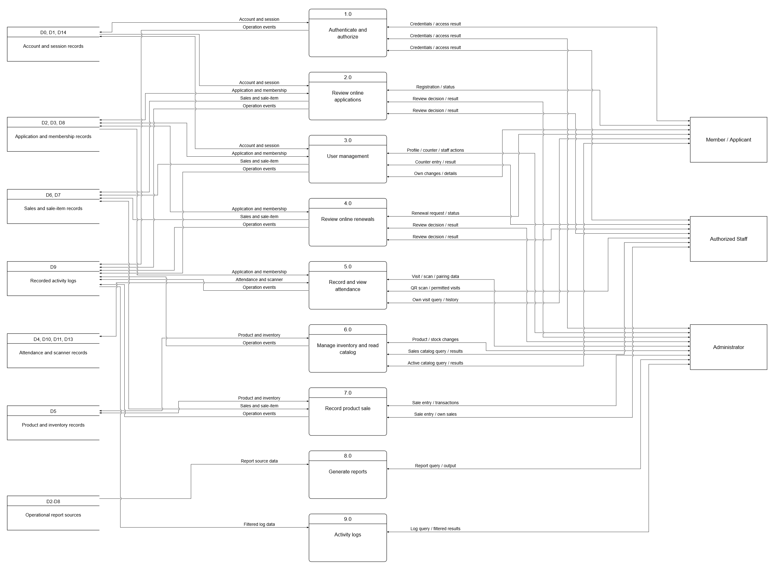
Figure 3. Summary Level 1 Data Flow Diagram - Gane-Sarson
Figure 3 summarizes the context process as nine numbered functions in one Level 1 overview. Processes 1.0 through 9.0 form the center column. Seven shared data-store groups appear on the left, while Member / Applicant, Authorized Staff, and Administrator each appear once on the right. Routed connectors link each function to the applicable stores and user group. Both sides therefore identify the actual destination of each exchange rather than repeating an independent store or actor beside every function. The figure uses forty-five summary connectors: twenty-three connect functions and grouped stores, and twenty-two connect functions and external actors. The detailed process descriptions retain the individual inputs, outputs, affected records, and permissions represented by these summaries. Vertical placement organizes the diagram and does not prescribe execution order.
Reading a process together with its labeled connections identifies who supplies or receives information and which records the function retrieves or changes. A connector with arrowheads at both ends summarizes distinct input/output or read/write directions; it does not mean that the same data travels both ways. A single arrowhead retains a one-way exchange: operational events flow toward the activity-log group, while report source data and filtered log data flow toward their reading processes. Small line bridges distinguish crossings from junctions, so a crossing does not combine the data on the two connectors. Each user group remains subject to its own permissions. For example, a member submits an application while an administrator or authorized staff member reviews it; a member reads their own attendance while an authorized operator records a scan. Members and staff may read the permitted product catalog, while inventory changes remain an administrator responsibility.
Store identifiers remain consistent with the detailed model. D0 represents managed Auth accounts, D1 profiles, D2 membership applications, D3 members, D4 attendance, D5 products, D6 sales, D7 sale items, D8 membership history, and D9 activity logs. D10 represents mobile pairing policy, D11 scanner pairing sessions, D13 private attendance scan requests, and D14 private account sessions. D12 is reserved for the retained scan-event table and is not presented as an active frontend feature. The shared groups are account and session records (D0, D1, D14); application and membership records (D2, D3, D8); attendance and scanner records (D4, D10, D11, D13); inventory (D5); sales and sale items (D6, D7); operational report sources (D2-D8); and activity logs (D9). These groups are logical summaries of existing sources, not additional physical tables. D2-D8 in reporting refers to the same operational stores already included in other groups. A two-way connection to a group means that the process reads the relevant records and writes the applicable records, not that it writes to every table in the group. Detailed effects appear in the process descriptions, and the ERD and data dictionary identify the actual database tables.
The actor-specific arrows are essential to interpreting User Management and attendance correctly. An administrator's profile-view query returns a read-only member profile. A member's personal-change request affects only their own permitted personal details. Staff arrows identify counter and attendance operations and do not include a profile query or personal-detail edit. Internal writes caused by registration, renewal, or server-side account provisioning describe the effects of an authorized operation; they are not a grant of general editing access to the underlying table. Authentication, role checks, database policies, and authorized functions support these boundaries even when different operations use the same data store.
Processes 8.0 and 9.0 have distinct outputs. Generate Reports reads operational records to produce the selected report and its supported preview or export. Activity Logs reads previously recorded events and returns the administrator's filtered results. Staff-account changes occur under User Management, and phone-pairing changes occur under QR Attendance administration. Their events may appear in the log, but the log viewer does not perform those changes. This separation prevents the model from treating monitoring an operation as permission to execute it.
- 1.0 Authenticate and Authorize
Supabase Auth verifies credentials and establishes the user session. The system reads the profile role and active-account state to route the account to the administrator, staff, or member interface. Authorization is enforced through database policies, role-checked functions, and Edge Functions, rather than relying on page visibility alone.
2.0 Review Online Applications. Applicants submit registration details and health declarations to membership_applications. Authorized staff and administrators review online requests and approve or reject them. Approval creates or links the member record, updates the application status, and records the applicable membership payment through sales and sale_items. Direct walk-in registration follows process 3.0 as a separate counter operation.
3.0 User Management. Administrators can view member profiles but cannot edit their personal information. They perform authorized membership operations and create or activate/deactivate staff accounts through authorized services. Members can retrieve and update only their own permitted personal details. Staff have a separate labeled counter flow: walk-in registration, limited member lookup, direct renewal, and active-member plan change. Staff cannot view or edit existing member profiles. Account rows created by the registration service describe backend storage, not profile-editing permission granted to staff. Membership changes record applicable member, history, sales, and sale-item updates.
4.0 Review Online Renewals. Members submit renewal requests to membership_applications. Authorized staff and administrators approve or reject these requests. An approved renewal preserves unused time by extending an active membership from its current expiry date; an expired membership restarts on approval. Approval updates the member, history, application status, and membership transaction records. Direct counter renewals by an administrator or staff operator belong to process 3.0 and are separate from the online Requests approval workflow.
5.0 Record and View Attendance. An authorized administrator or staff operator scans a member QR code with a supported computer or phone camera. The database validates the operator and member, checks for an open visit, and records check-in or check-out in attendance. recorded_by and checked_out_by identify the operators for each event. Private attendance_scan_requests records support duplicate-request protection. Paired phones additionally use administrator-managed pairing sessions and policy; pairing does not replace operator authentication. Members can read their own attendance history. Authorized staff and administrators read attendance within their permitted scope. Administrator-only phone-pairing creation, settings and removal belong to this attendance workflow. Staff and members do not receive those administration controls. A phone without an active pairing displays Phone not paired and must scan an administrator-generated pairing QR before member attendance scanning. The setup QR expires after ten minutes; successful pairing lasts thirty days from pairing time unless removed earlier. Reopening the camera does not renew that period. Missing check-outs from a previous Philippine calendar date are labeled Incomplete; current-day open visits remain checked in. The display does not invent a check-out time.
Phone pairing capacity counts both paired devices and unexpired pending QR reservations. At the initial two-slot limit, the permitted combinations are two paired phones, one paired phone plus one pending QR, or two pending QRs. Scanning a reserved QR completes that reservation without allocating another slot. Creating a further QR is blocked at capacity, while an existing pending QR remains available to scan. Each browser installation has its own identifier; another installation cannot take over an assigned QR. The device label is descriptive information and does not provide hardware attestation. An expired, removed, or unsuccessful pairing is not counted as a completed device connection.
6.0 Manage Inventory and Catalog. Administrators maintain product details, prices, stock, product forms, and active or archived state. Powder supplements support weight units; drinkable supplements support volume units; capsules and tablets use pieces or boxes; other supplements and merchandise use items. Sale processing converts compatible quantities and deducts stock using the configured inventory units. Members browse active products, and staff obtain the permitted catalog needed for sales; these read operations do not grant inventory-maintenance permission.
7.0 Sales
Administrators and staff record in-person product purchases for members or walk-in customers. The sale operation validates quantities and product status, writes sales and sale_items, and deducts product stock. Membership charges are recorded through the membership operations in processes 2.0 to 4.0. The database retains the existing receipt_number field as an internal transaction identifier. The documented operating process does not provide customers with receipts.
8.0 Generate Reports
Administrators select a report type and period to retrieve the relevant operational records. Supported outputs include preview, print layout, individual PDFs, and combined ZIP export. This reporting process does not manage staff access, phone pairings, or activity-log filters.
9.0 Activity Logs.
Administrators review database-recorded actions using date, account, action, and area filters and pagination. Logs include recorded staff-account changes and phone-pairing events. The interface reads activity_logs; it does not create staff accounts, alter pairing settings, or modify the recorded events. Those operations occur in User Management or QR Attendance and produce their own log entries.

Use Case Diagram
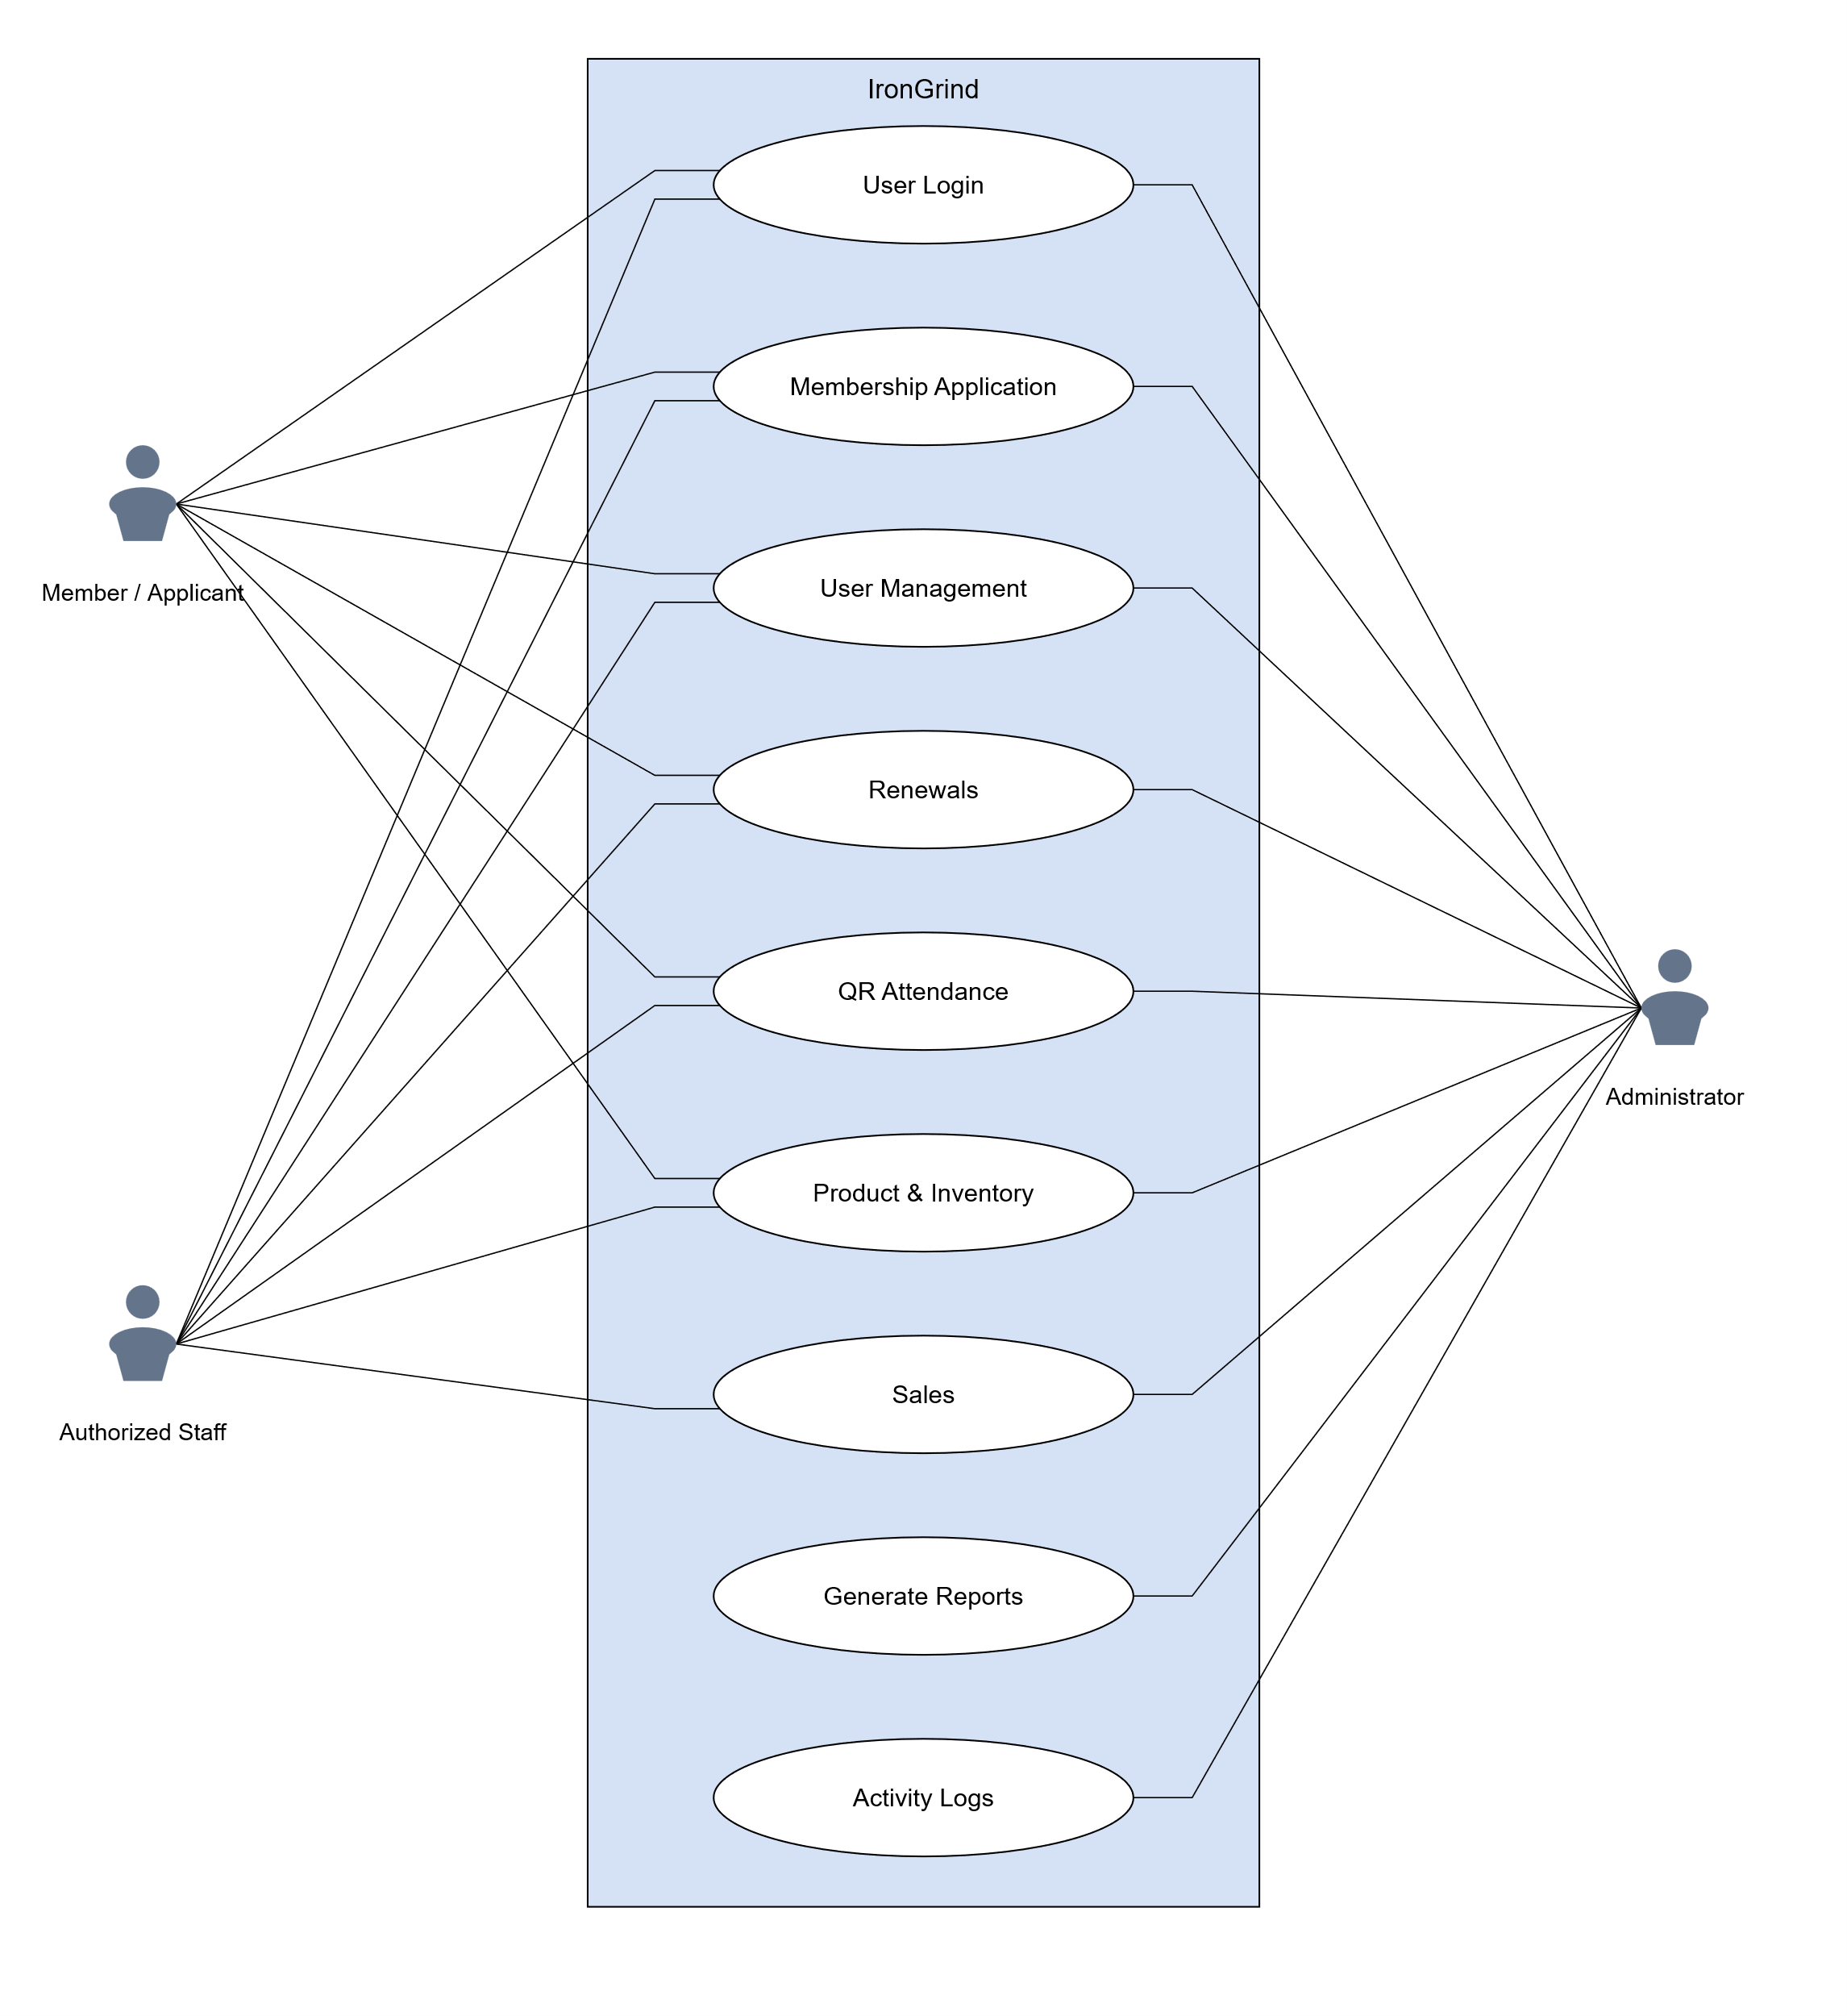
Figure 4. UML Use-Case Diagram
Figure 4 presents the IronGrind Membership and Operations Management System as a UML use-case diagram organized around the nine main functions in the functional requirements. The use cases are User Login, Membership Application, User Management, Renewals, QR Attendance, Product & Inventory, Sales, Generate Reports, and Activity Logs. Each oval represents one function-level capability, while the enclosing rectangle identifies the system boundary. The three external actors are Member / Applicant, Authorized Staff, and Administrator. They are represented by labeled head-and-shoulders icons outside the boundary. The diagram shows which actors participate in each function, while the accompanying explanations distinguish the particular tasks and permissions available to each role.
The diagram contains twenty-two solid actor-to-use-case associations: six for Member / Applicant, seven for Authorized Staff, and nine for Administrator. These plain lines indicate participation; they do not show data movement, screen navigation, or the chronological order of operations. Crossings do not create additional relationships. No include, extend, or actor-generalization relationship is asserted. Because the nine ovals are broad functions, an association does not give an actor every action within that function. User Management is the clearest example: all three actors participate, but they perform different operations on different permitted information.
Member / Applicant represents a prospective applicant and an existing member at their respective stages of interaction with the gym. This actor is associated with User Login, Membership Application, User Management, Renewals, QR Attendance, and Product & Inventory. Application submission and application-status information relate to the registration stage, whereas the registered member uses personal membership and self-service features. Access to protected member information remains subject to the implemented account and membership checks. The actor is not associated with Sales, Generate Reports, or Activity Logs, because these are operator or administrator functions rather than member purchasing or oversight privileges.
Authorized Staff participates in User Login, Membership Application, User Management, Renewals, QR Attendance, Product & Inventory, and Sales. These associations cover authorized request review, attendance handling, supported counter membership services, access to the sales catalog, product-sale recording, and review of the operator's own product sales. They do not give staff general access to member profiles, inventory maintenance, staff-account administration, phone-pairing administration, administrator reports, or activity logs. Administrator is associated with all nine functions and performs the operational and supervisory actions permitted by the administrator workflow. Its broader participation still respects the implemented restriction that member personal profiles are viewed without editing their personal details.
User Login verifies an account and establishes access to the interface permitted for its role and account state. All three actors participate in this function. A successful credential check is followed by the applicable role and active-account checks; the existence of a login association does not authorize access to another role's operations. Authentication and authorization are prerequisites to protected actions even though the diagram does not draw an include relationship from every other oval to User Login.
Membership Application covers online registration submission and its review. The applicant supplies the required registration information and receives the recorded application status. An authorized staff member or administrator reviews the limited pending-request details and records an approval or rejection. Approval is performed through an authorized server-side operation that rechecks the operator and pending state, prevents repeat processing, and creates or links the appropriate member and membership transaction records. The applicant's association represents submitting and checking the request, while the operator associations represent review and processing. They are different responsibilities within one functional area, not interchangeable permissions.
User Management includes role-specific account, personal-profile, and counter membership responsibilities. Administrators view member profiles without editing their personal details and control supported staff-account access. Members alone update their own permitted personal-profile details. Staff register walk-in members and process direct renewals or active-plan changes using limited lookup information. Those counter operations create or update the records required for the authorized membership transaction; they do not provide a general member-profile viewer or an existing-profile editing function. All three User Management associations are therefore intentional and match the functional requirement. The administrator and member associations must not be interpreted as granting the same personal-information editing rights.
Renewals allows a member to submit an online renewal request and obtain its status, while authorized staff and administrators review and approve or reject the request. Approval updates the linked membership, records the applicable renewal history and transaction, and saves the review decision. The online request workflow is distinct from a direct counter renewal, which is described under the operator responsibilities of User Management. Both workflows concern membership continuation, but the broad Renewals association does not let a member approve a request or directly change the recorded membership dates.
QR Attendance has different member and operator uses. The member displays their own QR code and views their own attendance history. Authorized staff and administrators scan the member QR and retrieve permitted visit information. The attendance service checks the member and current visit state before recording a check-in or check-out with its timestamp and operator. The member's association does not mean that a member can record attendance for themselves or another person. Administrator-managed mobile pairing supports the scanning arrangement, while staff scanning remains subject to operator authorization rather than permission to administer paired devices.
Product & Inventory combines product viewing with administrator maintenance. Members browse the active product catalog, and staff read the product information permitted for their sales tasks. Administrators maintain supported product details, prices, units, stock, and active state. All three actors are connected because they participate in this functional area, but only the administrator maintains inventory. Catalog access does not establish an online member checkout, authorize a stock adjustment, or permit a staff member to change product information.
Sales is associated with Administrator and Authorized Staff. Authorized operators enter the relevant customer and product-sale details, while the system validates the item, sale unit, quantity, price, and available stock, records the sale and line items, and applies the corresponding stock deduction. Staff may review their own product-sale records; the association does not imply unrestricted access to other operators' sales. Members are not connected to Sales because the implemented workflow records transactions through an operator. A saved system transaction or its internal receipt_number reference does not establish that the system issues a customer receipt.
Generate Reports and Activity Logs are administrator-only use cases. Generate Reports retrieves supported operational information for the selected report and its available preview or export. Activity Logs retrieves recorded events using the supported filters and paging controls. Neither function is associated with Member / Applicant or Authorized Staff. Reading an event in the log is also distinct from performing the action described by that event; the log viewer does not execute membership changes, inventory changes, account changes, or pairing controls.
The use-case diagram and the DFD describe complementary aspects of the same nine-function system. Figure 4 identifies actor participation and functional scope, while the DFD identifies the information exchanged with processes and stores. The ERD and data dictionary describe the persistent records affected by the authorized operations. Their shared function names support consistency across the chapter, but a diagram association is not an access-control mechanism. Database policies, active-role checks, authorized functions, and server-side services enforce the restrictions described here. The system-flow discussion that follows explains how these responsibilities operate together in the implemented workflows.
End-to-end system flow. Each protected operation begins with authentication and an active-role check. Page visibility alone does not authorize a database change; database policies, role-checked functions, or authorized server-side services validate privileged operations.
1. Applicant account and request. A prospective member creates an account with email and password through Supabase Auth before the online application is reviewed. The application is stored separately with its applicant account link and a pending status. Submission alone does not create an approved member record or active membership.
2. Review and membership activation. Authorized staff or an administrator loads limited pending-request details, confirms that payment was received at the gym, and chooses approve or reject. The server rechecks the active role, locks the pending request, and prevents a second review. Rejection records the decision. Approval of registration creates the member record linked to the existing Auth account; approval of renewal updates the membership dates. Approved requests also record the membership transaction, and renewals add a membership-history event.
3. Member self-service. A member signs in with email to view their own membership, progress, QR code, attendance history, and active catalog. They may update permitted personal details and submit a renewal request. A member can access only their own records; administrator profile viewing is read-only, and staff have no member-profile viewing or editing permission.
4. Counter and attendance operations. For walk-in registration, authorized staff or an administrator enters the member name and membership details; a server-side service creates the required account, profile, member, and transaction records. Direct renewal and active-plan change use limited member lookup and an authorized function, not a member-profile screen. For attendance, an authenticated operator scans the member QR; the service checks the member and existing open visit, then records check-in or check-out with its timestamp and operator. Phone pairing is administrator-managed and remains separate from operator sign-in. An earlier-date visit without check-out is shown as Incomplete without inventing an exit time.
5. Products, sales, and oversight. Administrators maintain the catalog, prices, product units, stock, and active state. Members and staff read only the catalog permitted for their role. When an operator records an in-person product sale, the service validates the item, unit, and available stock, saves the sale and line item, and deducts the quantity. IronGrind records payment at the gym but does not issue a customer receipt. Staff may review their own product sales. Administrators separately generate reports and read filtered activity logs; the log viewer does not perform the logged operations.
1. Authenticate Account
Supabase Auth verifies credentials. Members sign in with the email address on their account; staff and administrators use their assigned usernames. Member registration collects an email and password, not a separate username, and the member dashboard displays the member's full name. The profile role and active-account state determine administrator, staff, or member access, with protected operations checked by server-side authorization. New member registration uses a visible password-strength indicator and blocks passwords that do not meet the Strong requirements: 8 to 128 characters, uppercase and lowercase letters, at least one digit, and at least one symbol. Confirmation must match the selected password. Auth and the member-creation service enforce the password policy on the server; staff-account creation uses a minimum of 12 characters with the same character requirements. Existing sign-in forms continue to accept account credentials without imposing registration validation on login.
Usernames and email addresses are checked for duplicates without regard to capitalization or surrounding spaces. Registration shows availability feedback and rejects account identifiers already in use. Server-side account and database checks support this validation. Dashboard sessions and attendance-scanner sessions are tracked separately. A new dashboard login replaces the earlier dashboard session without closing a staff or administrator attendance scanner; a new scanner login replaces the earlier scanner session without closing the dashboard. The older online page checks session ownership about every five seconds and returns to sign-in when replaced. Offline or suspended pages check when they resume or reconnect.
2. Register and Submit Membership Application. An applicant creates an account using an email address and password, then submits personal and health information for review by authorized staff or the administrator. Name fields accept names containing letters and reject numeric characters.
3. Review Membership Applications. Authorized staff and the administrator review pending application summaries and approve or reject requests according to the gym's criteria, confirming in-person payment before approval.
4. Create or Link Member Account. Approval by an authorized staff member or administrator links an online application to the approved member record. Direct walk-in registration by an authorized administrator or staff operator uses a server-side Edge Function to create the appropriate Auth, profile, member, and payment records.
5. View Application status at Login. The User can check the current status of their membership application when signing in to see if it is pending, approved, or rejected.
6. View Membership Dashboard. This function allows the User to access their personalized dashboard, displaying their active membership plan, time-based progress, and their unique QR code.
7. User Management. The administrator can view member profiles but cannot update their personal details. Only members update their own permitted personal profile fields. Administrator membership operations, staff-account controls, and membership-history review are separate from personal-profile editing. Staff have no member-profile viewing or editing function.
8. Record Membership Attendance. An administrator or authorized staff operator scans a member QR code using a supported computer or phone camera. The system records a check-in or check-out and the responsible operator.
9. View Personal Attendance History. A member can view their own visit dates and recorded check-in and check-out times. A visit without a recorded check-out does not display an invented exit time.
10. View and Update Own Profile. A member can view their own profile and update permitted personal details. The administrator may view member profiles but cannot edit them. Staff have no access to member profile viewing or editing.
11. Browse Active Product Catalog. The User can view the available supplements and merchandise sold by the gym.
12. Manage Products and Inventory. The Admin can add, update, and monitor the product catalog, ensuring that merchandise stock quantities and supplement details are accurate.
13. Record Product Sale. An administrator or staff operator records an in-person product purchase, with validated quantities, saved sales and line items, and corresponding stock deduction. Staff can review their own product-sale records. No receipt provision is included in the documented operating process.
14. Submit Membership Renewal Request. This function allows a member to submit a renewal request at any time, subject to approval by authorized staff or the administrator. If approved while the membership is active, the new membership duration is added after the current expiry date. If approved after expiration, the renewed period begins on the approval date.
15. View Dashboard and Operational Reports. The Admin can view a summarized dashboard showing active members, daily sales, and attendance, as well as access specific operational reports.
16. Export Reports. This function allows the Admin to generate, download, or print detailed reports for record-keeping and business analysis.
17. Activity Logs and Related Administration. The administrator reviews recorded activity through the Activity Logs use case. Staff-account changes are performed under User Management; phone-pairing changes are performed under QR Attendance administration. These operations generate log entries but are not performed inside the read-only log viewer. Business approval or expiry email notifications are not included as implemented use cases.

Entity Relationship Diagram

Figure 5. Public-Schema Entity Relationship Diagram
The public-schema ERD in Figure 5 presents the persistent data structure of the IronGrind Membership and Operations Management System. It contains all twelve public tables and a separate auth.users reference managed by Supabase. The public tables support account profiles, membership applications and renewals, member records, attendance, membership history, products, sales, sale items, activity logging, and mobile attendance pairing and scanning. The Auth reference is not a thirteenth public application table. All eighteen foreign keys on public tables are represented: nine solid black connections between public tables and nine pale gray dashed connections to auth.users. Selected attributes keep the one-page overview readable; the data dictionary provides all 162 public field definitions.
In Figure 5, a relationship line links a referenced table to a table that stores its foreign key; it does not show the order in which screens or program operations execute. PK identifies a primary key, FK a foreign key, and UQ a unique constraint or index. A circle denotes zero, a bar denotes one, and a crow's foot denotes many. A mandatory foreign key requires exactly one parent record, whereas a nullable foreign key allows zero or one parent. A parent may have zero or many child records unless a unique or primary-key constraint limits the referencing field to at most one. Solid and dashed connections both represent declared foreign keys: the dashed style only distinguishes Supabase identity references and does not mean that enforcement is optional. Crossings without junction symbols do not establish additional relationships. Varchar(n) gives the declared character limit; numeric(p,s) gives the total precision and decimal scale; timestamptz abbreviates timestamp with time zone. Column nullability, defaults, and referential actions are specified in the data dictionary rather than inferred from the line color.
The core entities preserve different kinds of operational information. Membership applications retain submitted registration or renewal requests and their review status. Members retains the current member and membership values, while membership_history preserves relevant values before and after lifecycle events. Attendance stores visits and the separate operators for check-in and check-out. Sales stores transaction headers, and sale_items stores the individual product or membership charges. Product names and prices captured in sale lines support historical records even when the current catalog changes. The retained receipt_number field is documented as an internal transaction identifier rather than evidence that a customer receipt is issued.
The complete application schema includes the twelve public tables in Figure 5 and three private supporting tables. The fifteen application-owned tables comprise twelve public and three private tables; the private tables are account_sessions, admin_login_attempts, and attendance_scan_requests. These three tables are outside the public-schema figure and remain documented in the complete fifteen-table, 174-field data dictionary. Their three foreign keys, together with the eighteen public foreign keys, give twenty-one application foreign keys in the full schema. Supabase manages auth.users separately, so its internal columns are outside the application-owned dictionary. UUID fields do not automatically establish relationships: activity_logs.actor_id and mobile_attendance_scan_sessions.paired_device_id have no declared foreign keys. The activity_logs card therefore has no enforced relationship line.
Supporting identity entity: auth.users. Supabase Auth manages this account table. Its user identifier links application records to the authenticated identity; Auth verifies sign-in credentials, while IronGrind role and active-account checks determine which protected functions the account may use.
1. profiles Entity. Each profile shares its primary key with auth.users and records the administrator, staff, or member role, account status, active flag, name, username, email, phone number, gender, and timestamps.
2. membership_applications Entity. This table stores submitted registration and renewal requests and retains them after review. It records request type, selected plan, status, submission time, and, after review, the reviewer and decision time. Registration requests link to the applicant Auth account; renewal requests also link to the existing member.
3. members Entity. The members table stores current personal details, membership plan, dates, status, and registration source. It may link to the original registration application and to an authentication account. Walk-in registration by an administrator or authorized staff member can create a member without a source online application. Current member information is separated from prior membership events retained in membership_history.
4. attendance Entity. Each visit references a member and stores its date and check-in and optional check-out timestamps. recorded_by and checked_out_by independently reference the Auth accounts responsible for the two attendance events.

5. products Entity. Products store category, price, stock, stock and sale units, supplement form and type, merchandise type, size, active or archived state, and image reference. Stock is numeric and supports product-appropriate weight, volume, piece, box, or item units.
6. sales Entity. Each row stores a transaction total, customer details, optional member reference, status, sold_at timestamp, and processing Auth account. The retained receipt_number column is an internal transaction reference; its technical name does not mean that a receipt is provided to the customer.
7. sale_items Entity. Each line belongs to one sale and optionally references a product. It preserves the item or membership label, category, quantity, unit, price, and line total. Membership charges have no product reference, and historical item labels remain available if a product reference becomes NULL.
8. membership_history Entity. History records reference a member and optionally the responsible Auth account. They retain renewal, plan-change, or expiry events and the membership values before and after the event.
9. activity_logs Entity. The log preserves event time, actor labels, action, entity details, changed field names, and descriptive information for administrator review. Its id is an identity primary key. Actor_id is nullable UUID data without a declared foreign key, so the figure correctly leaves this table without an enforced identity relationship. Logging data describes recorded operations and does not itself authorize them.
10. mobile_attendance_scan_sessions Entity. A scanner session stores its token hash, creating Auth account, creation and expiry times, pairing details, and remembered-phone state. Created_by is a required foreign key to auth.users. Paired_device_id is retained UUID data without a declared foreign key. The session and token support the paired attendance workflow; a pairing does not replace the required operator authentication.
11. mobile_attendance_scan_events Entity. Each retained scan event requires one scanner session through session_id and records a QR payload and creation time. Its presence in the physical schema does not establish that a dedicated scan-event review interface is part of the current frontend. The dictionary records the payload length check and the session deletion rule.
12. mobile_attendance_pairing_policy Entity. The singleton primary key and its true-value check identify one policy row. The table stores the pairing limit, update time, optional updating Auth account, and credential hashes used for pairing administration. Its max_pairs check allows values from 2 through 50. The configured capacity counts paired phones and unexpired pending QR reservations according to the implemented pairing workflow.
Auth Users to Profiles and Members. An Auth account can have at most one profile and at most one linked member record. Each profile requires an Auth account; a member record can exist without an Auth link. Administrator, staff, and pending-applicant accounts need not have a linked member record.
Members to Membership Applications. The figure shows two different foreign keys between these tables. Members.application_id references membership_applications.id and is nullable and unique: a member may refer to zero or one source application, and an application can be referenced by zero or one member through that column. Separately, membership_applications.member_id references members.id and is nullable without a unique constraint, allowing a member to have zero or many requests and a request to have zero or one linked member. Online renewals use the request member reference to identify the existing member. A new registration may exist without a member_id, while the resulting member can retain the source application through application_id.
Members to Attendance. A member can have zero or many visit records, while each attendance row requires exactly one member through attendance.member_id. Each visit stores a check-in and may later store a check-out. Operator references recorded_by and checked_out_by are documented as separate authentication foreign keys in the dictionary; they are outside this core relationship line.
Members to Sales. A member can be associated with zero or many transaction headers. Because sales.member_id is nullable, an individual sale can reference zero or one member; a walk-in customer therefore does not require an existing member row. The transaction retains its customer label, total, status, timestamp, and internal reference independently of whether a member is linked.
Members to Membership History. Each history record requires one member through membership_history.member_id. A member can have zero or many historical events. The record preserves applicable prior and resulting plans, prices, and dates so that changes can be interpreted separately from the current member values. The referenced member cannot be deleted while a restricting history reference remains.
Sales to Sale_Items. Every sale_items row requires exactly one sales row through sale_id. A sale can be referenced by zero or many line rows at the foreign-key level; this schema minimum does not establish that the sale-recording workflow accepts an empty transaction. The header records the transaction total and customer information, while the lines preserve each product or membership charge, quantity, unit price, and line total. ON DELETE CASCADE removes dependent line rows when their parent sale is deleted.
Products to Sale_Items. A catalog product can appear in zero or many sale lines. Each line may reference zero or one product because product_id is nullable. Membership charges do not require a product reference. The saved item label and price preserve transaction details, and ON DELETE SET NULL clears the product reference rather than deleting the historical line when the referenced product is removed.
Additional Public Relationships. Profiles.id is both a primary key and a foreign key to auth.users.id: every profile belongs to one Auth account, while an Auth account may exist without a profile. Members.auth_user_id is nullable and unique, allowing a member record without an online account and at most one linked member record per non-null Auth account. Membership_applications.auth_user_id is nullable and is not unique, allowing multiple applications to reference the same account. The nullable operator references are attendance.recorded_by, attendance.checked_out_by, sales.processed_by, membership_history.recorded_by, and mobile_attendance_pairing_policy.updated_by. Mobile_attendance_scan_sessions.created_by is required. These nine identity references are the dashed connections in the figure. Separately, membership_applications.reviewed_by optionally references profiles.id, and each mobile_attendance_scan_events row must reference one scanner session through session_id; a session may have no scan-event rows or many. The private supporting relationships are documented in the dictionary.
Overall Description
Figure 5 covers all twelve public tables and their eighteen foreign-key relationships, with auth.users included only as a referenced identity table. All fifteen application tables and twenty-one foreign keys remain documented in the dictionary. Its Name, Type, Constraints, and Description columns record field purposes, actual field names and declared types, primary/foreign/unique key roles, composite-key membership, referenced columns, nullability, deletion/update actions, and relevant checks. For example, attendance.member_id uses ON DELETE CASCADE while membership_history.member_id uses ON DELETE RESTRICT. The retained receipt_number column is an internal transaction reference; it does not establish customer receipt issuance. A relationship line does not grant permission to view or modify records, because role checks, policies, and authorized functions control access.

Data Dictionary
The data dictionary uses four columns: Name, Type, Constraints, and Description. Name identifies the actual database column. Type includes declared character limits and numeric precision/scale, such as varchar(150) and numeric(12,2); text[] denotes an array of text values, and timestamptz denotes timestamp with time zone. Constraints identifies primary keys (PK), foreign keys (FK), unique constraints or indexes (UQ), required or nullable state, referenced schema/table/column, update/deletion actions, composite-key membership, identity generation, and relevant CHECK rules. Nullable at column level remains subject to any conditional check stated in the row. Text and JSON types have no declared character maximum unless a separate check imposes one. Description explains the operational purpose of each field. Table-purpose paragraphs and the ERD discussion explain the wider system context. The tables are arranged from account and membership records to attendance, products and sales, membership history, audit logging, mobile scanner support, and private security and request-processing support. Each table retains the schema-qualified name and its operational purpose. Repeated header rows and consistent column widths support reading across page breaks; each field row keeps its name, declared type, constraints, and purpose together.
Legacy identifier fields. Members sign in using their email address. New member records do not receive a username; members sign in using email. Current member registration uses email and does not collect a username. The nullable username columns in members and membership_applications remain for compatibility. The profiles.username field supports assigned staff and administrator identifiers. Their presence in the schema does not mean that member registration collects a username.
Table 6: profiles
Stores account-facing profile details, administrator/staff/member roles, account status, active-account controls, contact details, and timestamps.
Name | Type | Constraints | Description
id | uuid | PK, FK. NOT NULL. References auth.users(id); ON DELETE CASCADE; ON UPDATE NO ACTION. | Uniquely identifies this record so that the system can retrieve it and relate it to other operational information without relying on a person or product name.
username | varchar(30) | UQ. Nullable at column level. Non-NULL values must be unique. | Stores the optional sign-in username for staff and administrator accounts. Members sign in using their email address.
full_name | varchar(150) | NOT NULL. | Stores the complete name submitted for the account, application, or member.
role | varchar(20) | NOT NULL. CHECK: admin, staff, or member. | Identifies the account role as admin, staff, or member.
account_status | text | NOT NULL. CHECK: pending, active, or disabled. | Stores the account-state value as pending, active, or disabled according to its database check constraint.
created_at | timestamptz | NOT NULL. | Records when the database record was created.
updated_at | timestamptz | NOT NULL. | Records the timestamp used to identify the latest update to the record.
email | varchar(254) | UQ. Nullable at column level. Non-NULL values must be unique. | Stores the email address associated with the account or submitted record.
is_active | boolean | NOT NULL. | Indicates whether the account or catalog record is enabled for its applicable workflow.
phone_number | text | Nullable at column level. | Stores contact information for the account.
gender | text | Nullable at column level. | Stores the gender value supplied for an account through the supported form.

Table 7: members
Stores each gym member's current personal details and membership information. Previous membership changes are recorded separately in membership_history.
Name | Type | Constraints | Description
id | uuid | PK. NOT NULL. | Uniquely identifies this record so that the system can retrieve it and relate it to other operational information without relying on a person or product name.
application_id | uuid | FK, UQ. Nullable at column level. References public.membership_applications(id); ON DELETE SET NULL; ON UPDATE NO ACTION. Non-NULL values must be unique. | Links a member record to the associated registration application when one exists.
full_name | varchar(150) | NOT NULL. | Stores the complete name submitted for the account, application, or member.
mobile | varchar(11) | Nullable at column level. | Stores a Philippine mobile contact number for the member or applicant.
plan | varchar(30) | NOT NULL. | Stores the name of the membership plan associated with the record.
start_date | date | Nullable at column level. | Records the starting calendar date of the requested or current membership period.
end_date | date | Nullable at column level. | Stores the membership end date retained by current and compatibility operations.
status | varchar(20) | NOT NULL. CHECK: active, expired, suspended, or inactive. | Stores the lifecycle or transaction state of the record.
paid | numeric(10,2) | NOT NULL. CHECK: at least 0. | Stores the recorded membership payment amount as a number.
fitness_goals | text[] | NOT NULL. | Stores the selected fitness-goal entries as an array of text values.
height | numeric(6,2) | Nullable at column level. | Stores the submitted height measurement as a decimal number.
height_unit | varchar(3) | Nullable at column level. CHECK: cm, in, or ft when not NULL. | Identifies the unit associated with the height measurement.
weight | numeric(6,2) | Nullable at column level. | Retains a compatibility weight measurement used by earlier or supporting data paths.
health_conditions | text[] | NOT NULL. | Stores declared health-condition entries as an array of text values.
other_medical_conditions | text | Nullable at column level. | Stores additional health-condition details supplied by the person.
signature_data | text | Nullable at column level. | Retains signature data submitted through the registration workflow.
created_at | timestamptz | NOT NULL. | Records when the database record was created.
auth_user_id | uuid | FK, UQ. Nullable at column level. References auth.users(id); ON DELETE SET NULL; ON UPDATE NO ACTION. Non-NULL values must be unique. | Links the record to a managed Supabase Auth account.
email | varchar(254) | Nullable at column level. | Stores the email address associated with the account or submitted record.
username | varchar(30) | Nullable at column level. | Retains a legacy username value for compatibility with older member records and lookups. New member records do not receive a username; members sign in using email.
date_of_birth | date | Nullable at column level. | Records the person's birth date for registration and personal-information records.
age | smallint | Nullable at column level. | Stores the recorded age value associated with the person.
sex | varchar(30) | Nullable at column level. | Stores the sex value submitted in the member or application form.
weight_kg | numeric(7,2) | Nullable at column level. | Stores the person's weight in kilograms as a decimal measurement.
emergency_contact | jsonb | NOT NULL. | Stores emergency-contact information.
plan_price | numeric(12,2) | NOT NULL. | Stores the monetary amount associated with the selected membership plan.
expiry_date | date | Nullable at column level. | Stores the explicit expiration date of the member's recorded membership period.
registration_source | varchar(40) | NOT NULL. | Identifies the workflow through which the member record was created, such as online application or an authorized counter registration.
signature_path | text | Nullable at column level. | Stores a signature reference or payload used by the applicable workflow.
updated_at | timestamptz | NOT NULL. | Records the timestamp used to identify the latest update to the record.

Table 8: membership_applications
Stores submitted registration and renewal requests with the information provided by the applicant. Review status, reviewer, and timestamps track each request through processing.
Name | Type | Constraints | Description
id | uuid | PK. NOT NULL. | Uniquely identifies this record so that the system can retrieve it and relate it to other operational information without relying on a person or product name.
full_name | varchar(150) | NOT NULL. | Stores the complete name submitted for the account, application, or member.
date_of_birth | date | Nullable at column level. | Records the person's birth date for registration and personal-information records.
age | integer | Nullable at column level. CHECK: 1-120 when not NULL. | Stores the recorded age value associated with the person.
sex | varchar(30) | Nullable at column level. | Stores the sex value submitted in the member or application form.
mobile | varchar(11) | Nullable at column level. | Stores a Philippine mobile contact number for the member or applicant.
height | numeric(6,2) | Nullable at column level. | Stores the submitted height measurement as a decimal number.
height_unit | varchar(3) | Nullable at column level. CHECK: cm, in, or ft when not NULL. | Identifies the unit associated with the height measurement.
weight | numeric(6,2) | Nullable at column level. | Retains a compatibility weight measurement used by earlier or supporting data paths.
emergency_name | text | Nullable at column level. | Retains the emergency contact person's name submitted with an application.
emergency_relationship | text | Nullable at column level. | Retains the applicant's relationship to the emergency contact person.
emergency_contact | text | Nullable at column level. | Stores emergency-contact information.
plan | varchar(30) | NOT NULL. | Stores the name of the membership plan associated with the record.
plan_price | numeric(10,2) | NOT NULL. CHECK: at least 0. | Stores the monetary amount associated with the selected membership plan.
start_date | date | Nullable at column level. | Records the starting calendar date of the requested or current membership period.
end_date | date | Nullable at column level. | Stores the membership end date retained by current and compatibility operations.
health_conditions | text[] | NOT NULL. | Stores declared health-condition entries as an array of text values.
other_medical_conditions | text | Nullable at column level. | Stores additional health-condition details supplied by the person.
fitness_goals | text[] | NOT NULL. | Stores the selected fitness-goal entries as an array of text values.
signature_data | text | Nullable at column level. | Retains signature data submitted through the registration workflow.
status | varchar(20) | NOT NULL. CHECK: pending, approved, or rejected. | Stores the lifecycle or transaction state of the record.
reviewed_by | uuid | FK. Nullable at column level. References public.profiles(id); ON DELETE NO ACTION; ON UPDATE NO ACTION. | Identifies the profile of the staff member or administrator who reviewed the application.
reviewed_at | timestamptz | Nullable at column level. | Records when the staff member or administrator reviewed the request.
created_at | timestamptz | NOT NULL. | Records when the database record was created.
auth_user_id | uuid | FK. Nullable at column level. References auth.users(id); ON DELETE CASCADE; ON UPDATE NO ACTION. | Links the record to a managed Supabase Auth account.
member_id | uuid | FK. Nullable at column level. References public.members(id); ON DELETE SET NULL; ON UPDATE NO ACTION. | Identifies the member related to this operational record.
application_type | varchar(20) | NOT NULL. CHECK: registration or renewal. | Distinguishes an initial registration application from a membership renewal request.
submitted_at | timestamptz | NOT NULL. | Records the submission timestamp associated with an application.
email | varchar(254) | Nullable at column level. | Stores the email address associated with the account or submitted record.
username | varchar(30) | Nullable at column level. | Retains a legacy username value on older application records. Current member registration uses email and does not collect a username.
emergency_contact_data | jsonb | NOT NULL. | Stores the structured emergency-contact payload associated with an application.
weight_kg | numeric(7,2) | Nullable at column level. | Stores the person's weight in kilograms as a decimal measurement.
signature_path | text | Nullable at column level. | Stores a signature reference or payload used by the applicable workflow.
Table 9: attendance
Stores one record for each member visit to the gym. Check-in and optional check-out timestamps support attendance history and visit tracking.
Name | Type | Constraints | Description
id | uuid | PK. NOT NULL. | Uniquely identifies this record so that the system can retrieve it and relate it to other operational information without relying on a person or product name.
member_id | uuid | FK. NOT NULL. References public.members(id); ON DELETE CASCADE; ON UPDATE NO ACTION. | Identifies the member related to this operational record.
date | date | NOT NULL. | Stores the date associated with the attendance row.
time_in | timestamptz | NOT NULL. | Records when the visit began.
time_out | timestamptz | Nullable at column level. | Records when the visit ended.
created_at | timestamptz | NOT NULL. | Records when the database record was created.
recorded_by | uuid | FK. Nullable at column level. References auth.users(id); ON DELETE SET NULL; ON UPDATE NO ACTION. | Identifies the Auth account responsible for recording the attendance or history event.
checked_out_by | uuid | FK. Nullable at column level. References auth.users(id); ON DELETE SET NULL; ON UPDATE NO ACTION. | Identifies the Auth account that recorded check-out.

Table 10: products
Stores products offered for sale, including prices, units, and inventory information. Active and archived product records support catalog management and sales history.
Name | Type | Constraints | Description
id | uuid | PK. NOT NULL. | Uniquely identifies this record so that the system can retrieve it and relate it to other operational information without relying on a person or product name.
name | varchar(120) | NOT NULL. | Stores the product's catalog name used in inventory and product selection.
category | varchar(20) | NOT NULL. CHECK: supplement or merchandise. | Classifies the product or sale line for the appropriate operational behavior.
price | numeric(10,2) | NOT NULL. CHECK: at least 0. | Retains the product price field declared in the physical schema.
stock | numeric(14,6) | NOT NULL. CHECK: at least 0. | Stores the available product quantity using the configured inventory unit.
size | varchar(30) | Nullable at column level. | Stores an optional size or package description used to distinguish applicable merchandise or products.
created_at | timestamptz | NOT NULL. | Records when the database record was created.
updated_at | timestamptz | NOT NULL. | Records the timestamp used to identify the latest update to the record.
is_active | boolean | NOT NULL. | Indicates whether the account or catalog record is enabled for its applicable workflow.
archived_at | timestamptz | Nullable at column level. | Records when a product was archived, when applicable.
image_path | text | Nullable at column level. | Stores the catalog image reference associated with the product.
price_per_unit | numeric(12,2) | NOT NULL. | Stores the product price for the configured pricing unit.
unit | varchar(12) | NOT NULL. CHECK: gram for powder, milliliter for drinkable, piece/box matching stock_unit for capsule/tablet, and item for other supplements or merchandise. | Identifies the unit associated with a product price or sale-line quantity.
stock_unit | text | NOT NULL. CHECK: gram/kilogram/ounce/pound for powder; milliliter/liter/fluid_ounce for drinkable; piece/box for capsule/tablet; item for other supplements or merchandise. | Identifies the unit in which inventory quantities are recorded.
merch_type | text | Nullable at column level. CHECK: when supplied for merchandise, apparel, accessories, drinkware, gym_gear, or other; must be NULL for supplements. | Identifies the merchandise classification, such as apparel, accessories, drinkware, gym_gear, or other.
supplement_form | text | Nullable at column level. CHECK: required for supplements with powder, drinkable, capsule, tablet, or other; must be NULL for merchandise. | Identifies the supplement form as powder, drinkable, capsule, tablet, or other where applicable.
supplement_type | text | Nullable at column level. CHECK: when supplied for supplements, protein, creatine, pre_workout, vitamins, amino_acids, or other; must be NULL for merchandise. | Classifies a supplement as protein, creatine, pre_workout, vitamins, amino_acids, or other.

Table 11: sales
Stores one transaction header with customer details, amount, status, optional member reference, internal transaction identifier, and processing operator.
Name | Type | Constraints | Description
id | uuid | PK. NOT NULL. | Uniquely identifies this record so that the system can retrieve it and relate it to other operational information without relying on a person or product name.
member_id | uuid | FK. Nullable at column level. References public.members(id); ON DELETE SET NULL; ON UPDATE NO ACTION. | Identifies the member related to this operational record.
customer_name | varchar(150) | NOT NULL. | Preserves the customer name supplied for the transaction.
items | jsonb | NOT NULL. | Retains a JSON transaction-item payload in the sales header.
total | numeric(10,2) | NOT NULL. CHECK: at least 0. | Stores the complete transaction amount in the sale header.
status | varchar(12) | NOT NULL. CHECK: nonempty normalized lowercase text (trimmed); no fixed status enumeration is declared. | Stores the lifecycle or transaction state of the record.
sold_at | timestamptz | NOT NULL. | Records the transaction timestamp.
receipt_number | varchar(64) | UQ. NOT NULL. Values must be unique. | Stores the existing internal transaction reference under its retained database column name.
customer_type | varchar(15) | NOT NULL. | Stores the customer classification recorded for the sale.
processed_by | uuid | FK. Nullable at column level. References auth.users(id); ON DELETE SET NULL; ON UPDATE NO ACTION. | Identifies the Auth account of the authorized operator who recorded the transaction.
Table 12: sale_items
Stores each product or membership charge associated with a sale. Item name and price are retained as a transaction snapshot if the catalog record later changes or is removed.
Name | Type | Constraints | Description
id | uuid | PK. NOT NULL. | Uniquely identifies this record so that the system can retrieve it and relate it to other operational information without relying on a person or product name.
sale_id | uuid | FK. NOT NULL. References public.sales(id); ON DELETE CASCADE; ON UPDATE NO ACTION. | Links each sale line to its transaction header.
product_id | uuid | FK. Nullable at column level. References public.products(id); ON DELETE SET NULL; ON UPDATE NO ACTION. | Links a sale line to its catalog product when applicable.
item_name | varchar(150) | NOT NULL. | Preserves the product or membership label as it was recorded for the transaction line.
category | varchar(20) | NOT NULL. CHECK: supplement, merchandise, or membership. | Classifies the product or sale line for the appropriate operational behavior.
quantity | numeric(12,3) | NOT NULL. CHECK: greater than 0. | Stores the quantity charged for a sale line, including fractional amounts where supported.
unit | varchar(12) | NOT NULL. CHECK: gram, kilogram, ounce, pound, milliliter, liter, fluid_ounce, item, piece, box, or membership. | Identifies the unit associated with a product price or sale-line quantity.
unit_price | numeric(12,2) | NOT NULL. CHECK: at least 0. | Stores the price charged per recorded sale unit.
line_total | numeric(12,2) | NOT NULL. CHECK: at least 0. | Stores the amount charged for an individual sale line.
Table 13: membership_history
Stores membership lifecycle events and the relevant membership values before and after each event. These records support administrative review and reporting without replacing the member's current details.
Name | Type | Constraints | Description
id | uuid | PK. NOT NULL. | Uniquely identifies this record so that the system can retrieve it and relate it to other operational information without relying on a person or product name.
member_id | uuid | FK. NOT NULL. References public.members(id); ON DELETE RESTRICT; ON UPDATE NO ACTION. | Identifies the member related to this operational record.
event_type | varchar(30) | NOT NULL. CHECK: expired, renewal, or plan_change. | Identifies the membership-history event as expired, renewal, or plan_change.
previous_plan | varchar(30) | Nullable at column level. | Records the plan before the membership-history event.
new_plan | varchar(30) | Nullable at column level. | Records the plan associated with the membership after the recorded event.
previous_price | numeric(12,2) | Nullable at column level. CHECK: at least 0 when not NULL. | Stores the membership price before the recorded event.
new_price | numeric(12,2) | Nullable at column level. CHECK: at least 0 when not NULL. | Stores the membership price after the recorded event.
previous_start_date | date | Nullable at column level. | Preserves the membership start date before the history event.
previous_expiry_date | date | Nullable at column level. | Preserves the membership expiry date before the history event.
new_start_date | date | Nullable at column level. | Records the start date after the membership-history event.
new_expiry_date | date | Nullable at column level. | Records the expiry date after the membership-history event.
notes | text | NOT NULL. | Stores supporting context about the membership-history event.
recorded_at | timestamptz | NOT NULL. | Records when the membership-history event was saved.
recorded_by | uuid | FK. Nullable at column level. References auth.users(id); ON DELETE SET NULL; ON UPDATE NO ACTION. | Identifies the Auth account responsible for recording the attendance or history event.
Table 14: public.activity_logs
Name | Type | Constraints | Description
id | bigint | PK. Identity (GENERATED ALWAYS). NOT NULL. | Uniquely identifies this record so that the system can retrieve it and relate it to other operational information without relying on a person or product name.
occurred_at | timestamptz | NOT NULL. | Records when the activity entry was captured.
actor_id | uuid | Nullable at column level. No foreign key is declared on this UUID column. | Retains the identifier of the account responsible for the logged operation.
actor_name | text | NOT NULL. | Preserves the actor name captured with the activity entry.
actor_role | text | NOT NULL. | Preserves the role captured when the activity was recorded.
action | text | NOT NULL. | Identifies the recorded action, such as creation, update, approval, check-in, or a phone-pairing event.
entity_type | text | NOT NULL. | Identifies the system area or table associated with the logged action.
entity_id | text | Nullable at column level. | Stores the identifier of the affected record when one is available.
record_label | text | NOT NULL. | Stores a readable label for the affected record.
changed_fields | text[] | NOT NULL. | Stores the field names associated with a recorded change as a text array.
details | text | NOT NULL. | Stores a descriptive account of the logged action.
Table 15: public.mobile_attendance_pairing_policy
Name | Type | Constraints | Description
singleton | boolean | PK. NOT NULL. CHECK: true; the primary key permits only one policy row. | Identifies the single configuration row for the phone-pairing policy.
max_pairs | integer | NOT NULL. CHECK: 2-50. | Limits paired phones plus unexpired pending QR reservations.
updated_at | timestamptz | NOT NULL. | Records the timestamp used to identify the latest update to the record.
updated_by | uuid | FK. Nullable at column level. References auth.users(id); ON DELETE NO ACTION; ON UPDATE NO ACTION. | Identifies the Auth account responsible for the recorded policy update.
pairing_password_hash | text | Nullable at column level. | Stores the hashed pairing password used by the authorized phone-pairing workflow.
pairing_removal_pin_hash | text | Nullable at column level. | Stores the hashed PIN used to authorize pairing removal.
Table 16: public.mobile_attendance_scan_sessions
Name | Type | Constraints | Description
id | uuid | PK. NOT NULL. | Uniquely identifies this record so that the system can retrieve it and relate it to other operational information without relying on a person or product name.
token_hash | text | NOT NULL. | Stores the hashed pairing token associated with the phone session.
created_by | uuid | FK. NOT NULL. References auth.users(id); ON DELETE CASCADE; ON UPDATE NO ACTION. | Identifies the Auth account of the administrator who created the phone-pairing session.
created_at | timestamptz | NOT NULL. | Records when the database record was created.
expires_at | timestamptz | NOT NULL. | Records when the pairing session expires.
paired_device | text | Nullable at column level. | Stores the descriptive label of the paired phone.
paired_at | timestamptz | Nullable at column level. | Records when the phone was paired.
remember_phone | boolean | NOT NULL. | Retains the original remembered-phone preference. Current successful pairings last thirty days.
paired_device_id | uuid | Nullable at column level. No foreign key is declared on this UUID column. | Identifies the browser installation assigned to the pairing. Nullable for legacy pairings.
Table 17: public.mobile_attendance_scan_events
Name | Type | Constraints | Description
id | uuid | PK. NOT NULL. | Uniquely identifies this record so that the system can retrieve it and relate it to other operational information without relying on a person or product name.
session_id | uuid | FK. NOT NULL. References public.mobile_attendance_scan_sessions(id); ON DELETE CASCADE; ON UPDATE NO ACTION. | Links a retained scan-event record to its associated phone-pairing session.
qr_payload | text | NOT NULL. CHECK: length 1-500 characters. | Stores the QR payload retained in the scan-event table.
created_at | timestamptz | NOT NULL. | Records when the database record was created.
Table 18: private.attendance_scan_requests
Name | Type | Constraints | Description
request_id | uuid | PK. NOT NULL. | Stores the unique request identifier used for duplicate attendance-request protection.
operator_id | uuid | FK. NOT NULL. References auth.users(id); ON DELETE CASCADE; ON UPDATE NO ACTION. | Identifies the Auth account that submitted the attendance request.
member_id | uuid | FK. NOT NULL. References public.members(id); ON DELETE CASCADE; ON UPDATE NO ACTION. | Identifies the member related to this operational record.
result | jsonb | NOT NULL. | Stores the saved attendance-processing result as structured JSON.
created_at | timestamptz | NOT NULL. | Records when the database record was created.
Table 19: private.admin_login_attempts
Name | Type | Constraints | Description
bucket | text | PK. NOT NULL. | Identifies the grouping used by the private administrator-login attempt tracker.
window_start | timestamptz | NOT NULL. | Records the beginning of the attempt-tracking window.
attempts | integer | NOT NULL. | Stores the number of attempts recorded for the associated tracking window.
Table 20: private.account_sessions
Name | Type | Constraints | Description
user_id | uuid | PK, FK. NOT NULL. References auth.users(id); ON DELETE CASCADE; ON UPDATE NO ACTION. Part of composite PK (user_id, session_scope); this column alone is not declared unique. | Identifies the Auth account owning the scoped session.
session_id | uuid | NOT NULL. No foreign key is declared on this UUID column. | Identifies the accepted Auth session.
session_created_at | timestamptz | NOT NULL. | Records session creation time for replacement ordering.
session_scope | text | PK. NOT NULL. Part of composite PK (user_id, session_scope); this column alone is not declared unique. CHECK: dashboard or attendance. | Separates dashboard and attendance sessions; CHECK limits values to dashboard or attendance.
Stores the active dashboard and attendance-scanner sessions. The composite primary key is user_id and session_scope.

Forms
The system uses registration, profile, renewal, member, inventory, sales, staff-account, and phone-pairing forms. Members submit online registration or renewal information and maintain their permitted profile details. Administrators review online requests, maintain products and stock, and manage staff and pairing access. Authorized staff use counter forms for walk-in registration, direct renewal, active-member plan change, and product purchases, and use Requests approval for online registration and renewal decisions. Attendance uses camera scanning under an authorized operator account. Completed payments and purchases are recorded as transactions; receipts are not provided to customers. Required fields, validation, and server-side role checks support consistent data entry.
The Create Staff Account form collects first name, optional middle initial, and last name in separate inputs. It formats a supplied initial with a period and combines the parts into the existing full_name value; separate name columns are not introduced. The form also checks username and Gmail availability, phone format, password strength, and matching confirmation. Staff directory access and activation controls remain administrator-only. The Requests approval view separately presents pending online registration and renewal summaries for authorized staff and administrator decisions, with in-person payment confirmation before approval.

Prototype
The following figures present the supplied browser-interface captures for IronGrind, organized by access, administrator, staff, member, and session workflows. Long captures appear in labeled parts with small overlaps for readability. The screenshots illustrate captured interface states; operational permissions follow the functional requirements, use cases, and workflow descriptions.

Access and Online Registration

Figure 6. Shared Sign-in Interface
The sign-in screen provides the account identifier and password inputs, password visibility control, sign-in action, password-recovery link, and entry point for new-member registration. Members use their email address; assigned staff and administrator identifiers are handled by the supported authentication workflow. The Remember my login option retains the login identifier rather than filling or storing a plaintext password. After successful authentication, the role and account state determine the permitted interface. The screenshot shows the access form and does not demonstrate a completed login or an authorized session.

Figure 7a. Online Membership Registration Form - Personal, emergency-contact, and membership information
The first part of the online registration form collects separate first, middle, and last names, date of birth, age, sex, mobile number, height, and weight. Emergency-contact fields identify a person to contact and their relationship to the applicant. The membership area presents the available plan choices and applicable date fields. These entries form the submitted application information; selecting a plan does not itself activate a membership. The following parts continue the same form. Small overlapping areas between the image parts preserve continuity without introducing additional records.

Figure 7b. Online Membership Registration Form - Health declaration, fitness goals, and agreements
The middle part records the applicant's health declarations and optional fitness goals, followed by the rules-and-agreement acknowledgment and liability waiver. These inputs document the information and acknowledgments supplied for membership review. They are not a medical assessment, a diagnosis, or a promise of a particular fitness result. The displayed options belong to the registration form; access to health-related records remains subject to the system's authorization rules. This image continues the same application shown in the preceding part.

Figure 7c. Online Membership Registration Form - Signature, portal credentials, and submission
The final part contains the digital-signature area and the account email, password, and confirmation fields. The applicant completes the required acknowledgments, provides the signature, and submits the membership application. Email identifies the member account; no separate member username is collected. Submission creates a pending registration workflow and does not constitute membership approval. Authorized staff or an administrator subsequently reviews the request, confirms the applicable in-person payment, and records the decision. The screenshot shows the submission controls, not the outcome of that review.

Administrator Interface
The administrator figures show operational summaries, membership records, request review, attendance and camera setup, inventory, transaction monitoring, reports, staff access, and audit review. These screens support administrator responsibilities without granting personal-profile editing rights over existing members.

Figure 8. Administrator Dashboard
The administrator dashboard provides a quick view of registration requests, current members, the selected day's check-ins and sales, and low-stock items. A request-review shortcut directs the administrator to the appropriate pending requests, while the sidebar opens the operational modules. The lower attendance area summarizes the available visits for the displayed day. These cards help identify work that needs attention before opening a detailed module. The amounts, counts, dates, and records visible in this screenshot are captured interface values and should not be interpreted as evaluated performance results or permanent system totals.
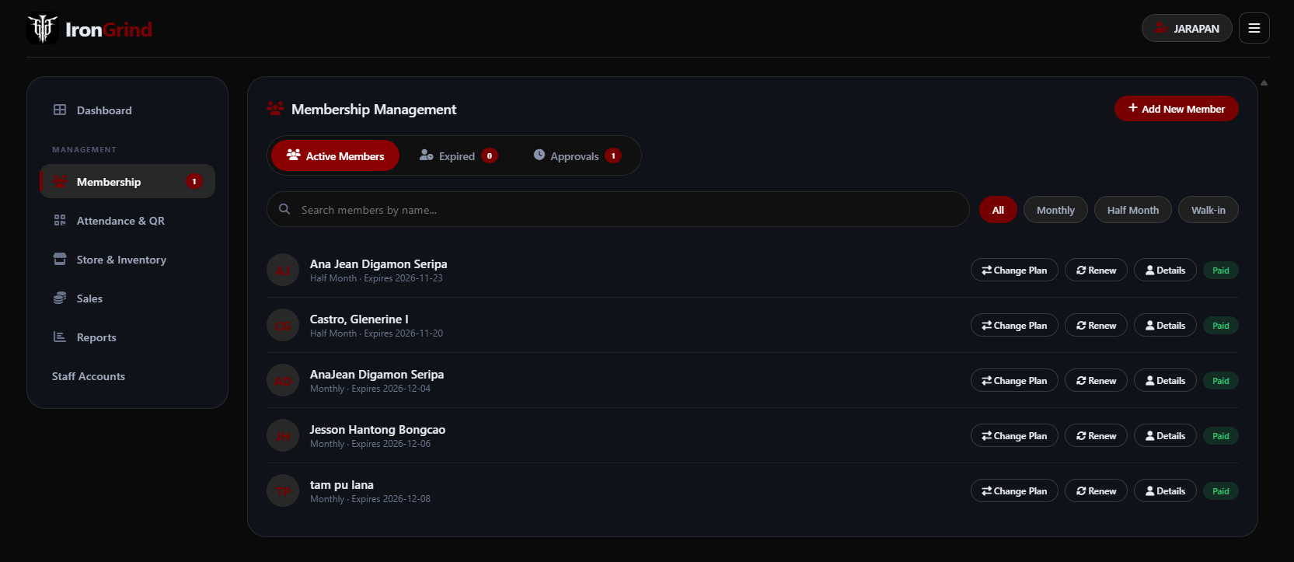
Figure 9. Active Membership Records
The active-membership view lists member records and provides search and plan filters. Each row exposes supported actions such as renewal, active-plan change, and viewing details, while the page also provides the add-member entry point and navigation to expired records and approvals. The administrator can use the limited operational controls to perform a membership transaction or inspect the permitted information. Viewing a member's personal details remains read-only. An association with User Management therefore does not mean that the administrator can directly edit an existing member's personal-profile fields.

Figure 10. Expired Membership View
The Expired tab separates expired membership records from the active list. Search and plan filters help the administrator locate the relevant record before taking a supported membership action. The captured view contains an empty-state message because no recently expired member matches the displayed filters. This state should not be interpreted as a missing module or evidence that the database contains no expired records under every possible query. A renewal is handled through the authorized membership workflow rather than by manually changing the status displayed in this list.

Figure 11. Online Registration Review
The approvals view separates new-registration requests from renewal requests and presents the information available for reviewing a selected application. The captured registration card includes the requested plan, applicable dates, contact and declaration details, signature, request status, and approval or rejection controls. The administrator confirms the applicable payment received at the gym before approving the request. The authorized review operation validates the pending state and records the decision and related membership transaction. Existing applicant authentication and subsequent membership activation are distinct stages; the visible approval button label does not redefine that account sequence.

Figure 12a. Administrator Walk-in Registration - Personal and emergency-contact information
The administrator's Add New Member dialog begins with the member's name, birth information, contact number, height and weight, and emergency-contact details. In this captured administrator dialog, the name appears as a full-name input. This differs from the staff add-member screen, which shows separate name fields. The form supports creating a new walk-in record; it does not provide a general interface for editing an existing member's personal profile. The remaining sections of the same dialog continue in the following image parts.

Figure 12b. Administrator Walk-in Registration - Plan, dates, declarations, and signature
The middle of the walk-in dialog presents the membership-plan choices and the relevant membership-date fields, followed by health declarations, fitness goals, and digital-signature capture. The operator records the details supplied for the in-person transaction and asks the applicant to provide the required signature. These controls support the membership record being created and the applicable payment entry. They do not authorize diagnosis or unrestricted personal-profile editing. The Clear control resets the captured signature when it must be entered again.

Figure 12c. Administrator Walk-in Registration - Portal credentials and record creation
The final section collects the new member's portal email, password, and matching confirmation and provides Cancel and Add Member controls. The operator completes the required information before submitting the walk-in registration through the authorized service. The service creates the applicable account, profile, member, and transaction records, with the member QR becoming available through the supported workflow. The screenshot records the form and its controls; it does not independently prove that a particular submission succeeded or that an existing member's account was modified.

Figure 13. Administrator Attendance and QR Workspace
The Attendance & QR workspace provides the scanner entry point, phone-camera pairing information, date selection, and attendance log. An authorized operator scans a member QR to record the applicable check-in or check-out after the service checks the member and visit state. The displayed log is filtered by the selected date; an empty log means no entries are shown for that state. Camera selection and phone-pairing controls are illustrated in the following figures. The screenshot does not show an active camera feed and is not evidence of a completed physical scan.

Figure 14. Attendance Camera Selection
The camera-selection dialog distinguishes a camera connected to the current device from a paired phone camera. Choosing This device starts the local camera workflow, while Phone camera opens the supported pairing workflow. The dialog also communicates the setup-QR expiry and the remembered-pairing period. These are different lifetimes: the setup code is temporary, whereas a completed pairing can remain valid for the configured period unless ended earlier. A paired phone still requires the appropriate operator authentication; pairing alone does not grant attendance-recording or administrator privileges.
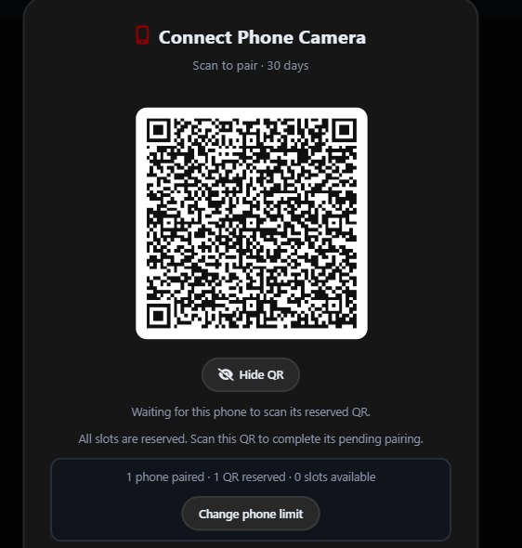
Figure 15a. Phone-Camera Setup and Pending Pairing - Setup QR and reserved capacity
The upper pairing view displays the setup QR, its visibility control, the current slot counts, and the administrator's phone-limit control. A pending setup QR reserves a pairing slot, so a fully reserved capacity can include both a paired phone and a QR awaiting its phone. The administrator shares the setup code with the intended scanning device and completes the supported pairing process. This is a phone-setup QR, not a member attendance QR, and the captured code is not presented as a reusable credential for a later session.
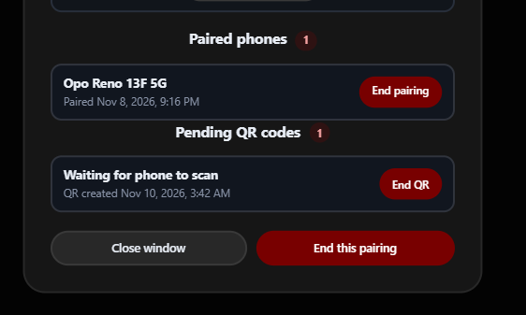
Figure 15b. Phone-Camera Setup and Pending Pairing - Paired phones and pending setup records
The continued view lists an already paired phone and a pending setup record. End pairing removes the selected completed pairing, while End QR cancels an unused pending setup code and releases its reservation. Closing the dialog is separate from ending an active pairing. The displayed counts explain how the configured capacity is shared and help the administrator remove an unused record before creating another setup request. These controls administer scanner connections; they do not replace the operator login needed for attendance transactions.

Figure 16. Pairing Capacity Reached
This pairing-dialog state shows that the configured phone limit has been reached and no free slot is available. The list identifies the paired devices and provides the supported removal controls. The administrator may end an unused pairing or change the permitted phone limit through the authorized settings workflow. The presence of a limit message is an expected capacity-control state, not by itself a camera malfunction. Counts in this capture describe that particular pairing state; they do not establish a tested maximum number of simultaneous system users or verified multi-phone performance.

Figure 17. Inventory Access Gate
The Store & Inventory screen is shown before the administrator has opened the protected inventory area. The access gate requests the supported store password and provides the Open Store action. This additional interface state is separate from the account login and does not grant inventory rights to staff or members. The server's role and authorization checks remain necessary even when the interface displays an unlock control. The supplied screenshot illustrates the locked state; the following inventory figure shows the product-management view after the applicable access requirements have been met.
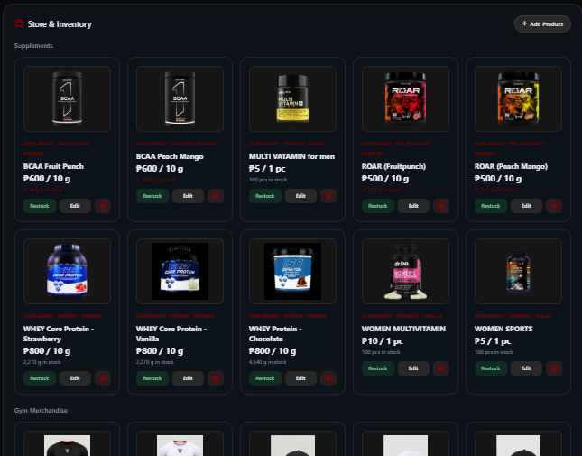
Figure 18a. Administrator Product and Inventory Catalog - Product cards and maintenance controls
The inventory catalog displays product cards with names, images, prices or sale units, current stock information, and the administrator's maintenance controls. The Add Product entry point supports creating a catalog record, while the card controls support the available edit, stock, and archive operations. These actions belong to the administrator workflow. Supplement records may use weight, volume, piece, or box units as configured; the visible units should be read from the individual product rather than assumed to be identical across the catalog.
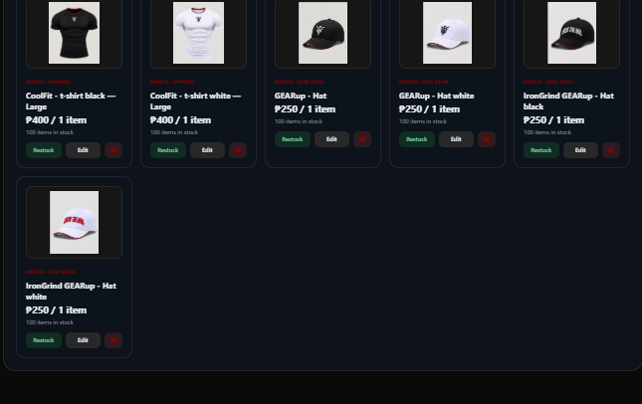
Figure 18b. Administrator Product and Inventory Catalog - Continued catalog and merchandise records
The continued inventory view includes further product cards and merchandise records such as shirts and headwear. Size, sale unit, price, availability, and stock information distinguish the relevant product variants. An inventory adjustment changes the applicable record through the authorized operation; it is not the same as recording a customer sale. Members and staff may see the catalog permitted for their roles, but they do not receive these inventory-maintenance controls. This part continues the same captured catalog rather than presenting a separate inventory database.

Figure 19. Membership Sales Monitoring
The Membership tab in Sales summarizes recorded membership income and transaction counts. Period and day filters determine which records appear, while the plan-category cards provide a breakdown of the selected results. The captured screen shows an empty transaction result for its filter state even though a broader overall-income card remains visible. These values have different filter contexts and should not be treated as directly interchangeable totals. The page monitors saved membership payments; it does not process an online payment or establish that a customer receipt was issued.

Figure 20. Product Sales Monitoring
The Products tab presents product-income information, including the supplement and merchandise breakdowns for the selected period or day. The New Sale control opens the supported product-sale workflow. Completed sales are recorded with their itemized details and the applicable stock deduction after validation. An empty transaction area indicates that no records match the current filter, rather than proving that no product sales exist. Administrator transaction monitoring is broader than the staff operator's own-sales review, and members do not receive a product-checkout function through this page.

Figure 21. Administrator Report Selection
The Reports page organizes report choices into membership, daily operations, and payment-and-sales areas. The visible cards include membership, member status, renewal, archive, attendance, inventory, payment, and sales reports, with filters for the requested scope and period. Selecting a supported report initiates its preview or export workflow. The supplied image shows report selection rather than an opened report preview or final print layout. Report figures must therefore be interpreted as interface navigation, not as evidence of a measured operational improvement or of a particular completed export.

Figure 22. Staff Account Creation and Directory
The administrator's Staff Accounts page combines the creation form and staff directory. The form separates first name, optional middle initial, and last name and collects the assigned username, Gmail address, contact and demographic information, password, and confirmation. The directory exposes supported account-details and activation controls. These administrator actions govern staff-account access; they are distinct from a member updating their own personal profile. Although the captured subtitle uses narrower attendance-only wording, the documented staff role also includes the authorized counter, product-sale, and request-review operations illustrated in the staff figures.
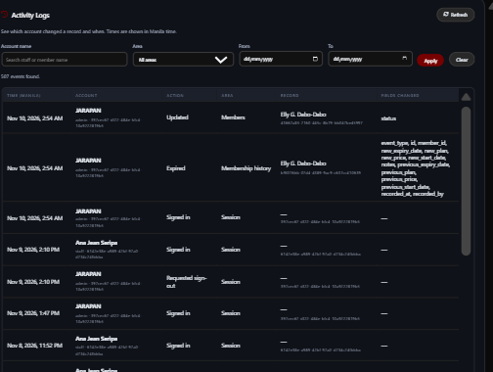
Figure 23a. Administrator Activity Logs - Filters and recorded actions
The Activity Logs screen presents filters for the actor, system area, and date range, together with controls to apply or clear the query and refresh the results. The visible rows identify event times, actors, actions, affected areas or records, and recorded field-change details. This is an administrator review interface. A log row describes an operation already recorded by the system; reading it does not execute that operation or grant permission to repeat it. The screenshot's sample events are captured records rather than a formal security or performance evaluation.
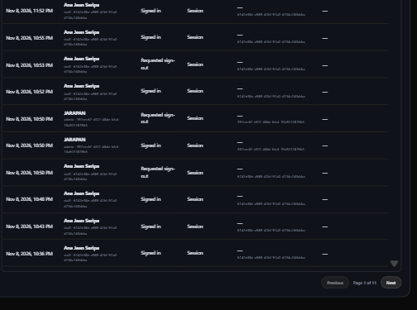
Figure 23b. Administrator Activity Logs - Continued results and pagination
The continued activity-log view shows additional recorded events and the paging controls used to move through the result set. Pagination changes which recorded rows are displayed without modifying the underlying operational records. The overlap with the preceding image part preserves continuity across the split capture and should not be interpreted as duplicate database entries. Staff and members do not receive this administrator log-viewing function. Audit review remains separate from the account, membership, inventory, or pairing actions whose events may appear in the list.

Authorized Staff Workspace
The staff figures show the separate workspace for attendance, product sales, counter membership services, and online request review. Its limited member lookup and request summaries support the authorized transaction without providing a general member-profile viewer or inventory-maintenance interface.
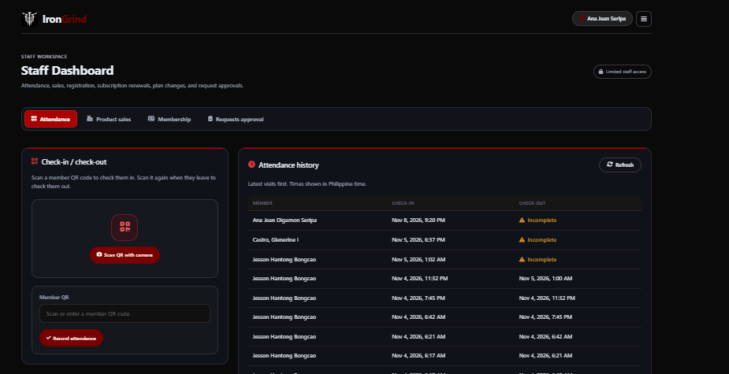
Figure 24a. Staff Attendance Workspace - Scanning controls and permitted visit records
The staff attendance view places the QR-camera action and manual QR entry beside the permitted attendance-history table. A staff operator submits a member QR through the supported scan operation, which validates the account and visit state before recording check-in or check-out. The table presents the resulting visit information and status rather than a member-profile editing function. Incomplete entries identify a previous-day visit with no recorded exit; the interface does not invent a missing checkout time. The remaining history continues in the next image part.
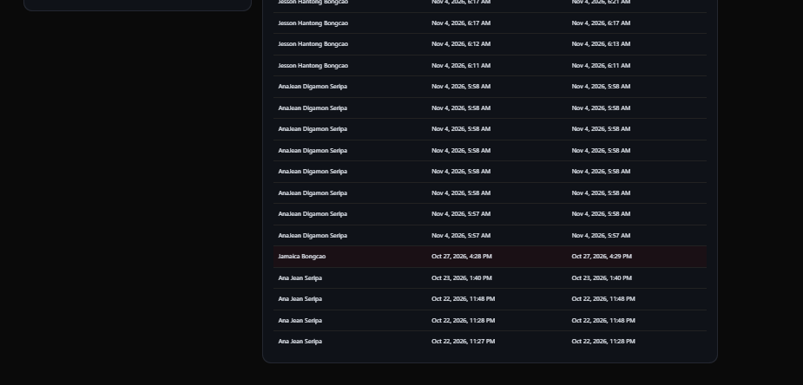
Figure 24b. Staff Attendance Workspace - Attendance-history continuation
The lower part continues the visit list shown in the preceding capture. Member names, visit times, and status labels support attendance review within the staff permission boundary. This list is operational attendance information, not general access to the member's personal, emergency-contact, or health profile. The small overlap between the image parts preserves the original table context and is a presentation choice only. A screenshot of existing visits does not independently establish that the laptop or phone camera completed a new scan during documentation preparation.
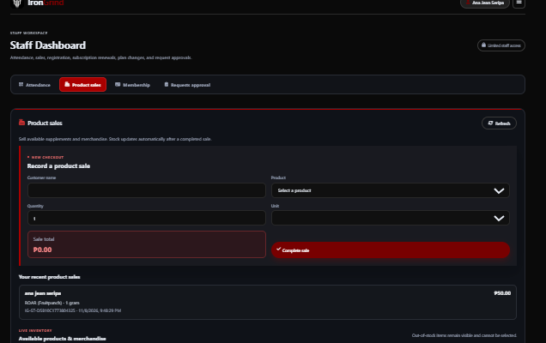
Figure 25a. Staff Product-Sale Workspace - Sale entry and the operator's recent sales
The staff Product sales tab provides customer-name, product, quantity, and unit inputs, shows the calculated sale total, and exposes the Complete sale action. The recent-sales area is limited to the staff operator's own product-sale records. A completed sale must pass the applicable product, unit, quantity, and stock checks before the transaction and line items are saved and stock is deducted. These sale controls do not grant permission to maintain inventory or inspect every operator's sales. The product-selection catalog continues below the form.
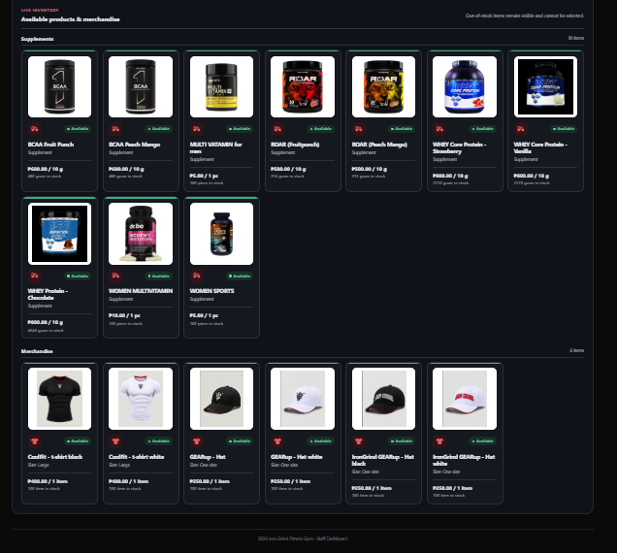
Figure 25b. Staff Product-Sale Workspace - Sales catalog and availability
The continued staff catalog groups supplements and merchandise and shows the images, product or variant information, sale units, prices, stock, and availability used for item selection. An unavailable item may remain visible for information but cannot be selected for a completed sale. The staff catalog supports the sales transaction; it is different from the administrator's maintenance catalog. It contains no general product-edit, restock, or archive permission. The visible items and quantities describe the captured catalog state and are not fixed product specifications of the documentation.

Figure 26a. Staff Counter Membership Services - Walk-in member and portal details
The staff Membership area separates Add Member, Renewal, and Change Plan actions. The captured Add Member form collects first name, optional middle initial, and last name separately, together with portal email and password, contact information, birth information, gender, and emergency-contact details. These inputs create a new walk-in record through the authorized service. They do not provide staff with a general screen for viewing or editing an existing member's profile. Renewal and active-plan changes use their own limited member lookup rather than unrestricted personal-profile access.

Figure 26b. Staff Counter Membership Services - Standard plan, signature, and transaction submission
The lower form allows the operator to choose the supported standard membership plan and capture the applicant's signature. The displayed restriction limits staff to the standard plans and prices available to their role. Clear signature resets the capture, while Create member & record payment submits the supported walk-in transaction after the required information has been completed. The action records payment received at the gym rather than processing an online charge. It is separate from reviewing a previously submitted online registration or renewal request.

Figure 27. Staff Online Request Approval
The Requests approval tab lists pending online registration and renewal summaries with only the information needed for the staff review decision. The operator confirms the applicable payment received at the gym and approves or rejects the selected request. The authorized review function rechecks the active role and pending state and prevents competing decisions from processing the same request twice. This limited request card is not a member-profile viewer. Its presence confirms that request review is a staff function within the documented scope, while administrator-only inventory, reporting, pairing, and staff-account controls remain outside this workspace.

Figure 28. Staff Account Menu
The staff account menu identifies the signed-in operator and provides the available light or dark appearance selection and logout action. Theme selection changes the presentation of the workspace, not the account's role or permitted operations. The captured staff menu does not expose the member Update Profile action or administrator management modules. The label and controls therefore support account awareness and session navigation while the application's authorization rules continue to restrict operational access. The logout action is illustrated separately by the final confirmation dialog.

Member Portal
The member figures show personal membership information, renewal requests, attendance, product browsing, and the profile menu. The member remains limited to their own records. Product browsing describes in-store availability rather than an online checkout service.

Figure 29. Member Membership Progress and Renewal
The member view presents the current plan, membership expiry, remaining days, and elapsed-membership indicators. This progress describes the passage of the membership period rather than workout performance, weight change, or a clinical fitness measure. The renewal area allows the member to choose a supported plan and submit an online renewal request for review. Submission does not immediately change the membership dates or approve the payment. An authorized staff member or administrator reviews the request, and an approved active renewal preserves the applicable unused membership time under the documented renewal rule.
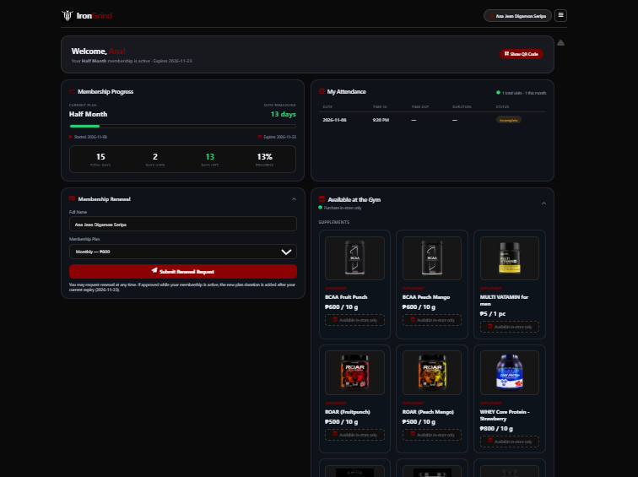
Figure 30a. Member Dashboard, Attendance, and In-store Catalog - Personal status, visits, renewal, and catalog entry
The dashboard combines the member's own membership summary, renewal controls, attendance area, Show QR Code entry point, and the beginning of the available-at-the-gym catalog. The attendance area concerns that member's own visits; an incomplete visit reflects a missing recorded checkout rather than a generated exit time. Show QR Code opens the personal code used by an authorized attendance operator. The supplied image shows the button rather than the opened QR display. The product cards introduce the in-store catalog and do not provide a member online checkout.
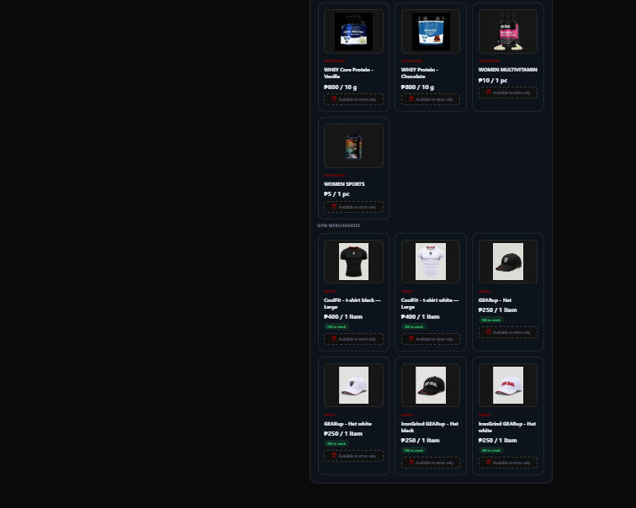
Figure 30b. Member Dashboard, Attendance, and In-store Catalog - Continued supplement and merchandise catalog
The remaining member catalog displays further supplements and merchandise with their images, descriptions or variants, prices, units, and the availability information provided by the interface. These cards help a member identify products sold at the gym. The member has no inventory-maintenance controls and does not complete a sale from this view; an authorized operator records an in-person purchase. This is the continuation of the same dashboard capture, including its naturally empty space beside the long catalog. The image has not been rearranged to imply additional dashboard features.

Figure 31. Member Profile and Appearance Menu
The member menu provides Update Profile, appearance selection, and logout. Update Profile leads to the permitted personal self-service workflow for the signed-in member, not a staff or administrator account-management interface. The menu screenshot shows the entry point rather than the opened edit form, so it should not be captioned as a complete profile-editing screen. The member may update only their own permitted details under the implemented validation and authorization rules. Theme selection affects appearance, while logout ends the account session through the supported confirmation flow.

Session Confirmation
The final interface figure shows the confirmation used before ending an account session. It is an interaction control rather than an additional main functional requirement.

Figure 32. Logout Confirmation Dialog
The logout dialog asks the account holder to confirm whether to end the current session. Cancel returns to the current interface, while Log out proceeds with the supported sign-out workflow. This confirmation reduces accidental navigation away from an active workspace but does not substitute for authentication or authorization. The picture is a captured interaction state, not an additional main function beyond the nine functional requirements. Remembering a login identifier is separate from retaining an authenticated session; confirming logout does not reveal a stored password or sign an account back in automatically.

Gantt Chart

Figure 33. Gantt Chart
The Gantt chart presents the planned development schedule for the Iron Grind System over ten weeks, from August 24 to October 28. The work is organized into three phases. During Planning (Weeks 1–4), the team identifies a potential client, interviews the client, gathers feedback, and confirms the system requirements and proposed features. During Design (Weeks 5–8), the team creates and refines the user-interface design and prototypes using the requirements and feedback gathered during planning. During Development (Weeks 9–10), the team begins implementing the frontend, backend, database, API, and supporting components while continuing work on the project chapters. The phases show how the project moves from understanding the gym’s needs to designing and developing the system.
The horizontal timeline indicates when each planned activity was assigned, while the colored marks associate the activity rows with the corresponding week. The chart should be read as a schedule of intended work rather than as proof that an activity was completed on that date. Its planning, design, and development groups organize the original sequence of work; they do not replace the iterative refinement described in the Agile methodology. Since the system has subsequently changed, the chart's dates are retained as the original plan and should be distinguished from any separately verified record of actual development or deployment.

REFERENCES
Pavlović, M. (2018, October 23). And from now on we are Agile ... (on enterprise or any other projects for that matter). LinkedIn. https://www.linkedin.com/pulse/from-now-we-agile-enterprise-any-other-projects-misa-pavlovic-

